Implementation Chapter

Introduction
This chapter presents the detailed implementation of a Zero Trust testbed designed to support empirical evaluation of identity-centric, policy-driven access control in software-defined environments. The work builds a baseline testbed focusing on criteria based access control decisions and score based trust evaluation testbed that build up on the former The primary objective of the testbeds is to demonstrate the transition from implicit network trust to explicit, continuously evaluated trust enforced across network and application layers. The design follows the NIST SP 800-207 Zero Trust Architecture (ZTA) reference model, explicitly separating Policy Decision Points (PDPs), and Policy Enforcement Points (PEPs). Further, the testbed clearly demarcates Policy Administration Points (PAPs) and the policy engine’s trust algorithm based on a multidomain and score based multi-criteria (score) trust estimation and calculation. The design prioritizes reproducibility, modularity, and extensibility to support multi-domain trust experiments.

TestBed Setup Procedure
The testbed design and setup was done systematically to clearly demarcate controller and gateway fucntions as defined by NIST SP 800-207 and CSA SDP dfintion. The process was split into 6 steps that sequentily built on each to deelop an incremental prototype to test the trust algorithm. The steps have been discussed and illustrated in figures 8.1 through to 8.4
- Host preparation: The goal of this step was selection and preparation of tehe host environment on which tesbed was setup. This was based on. Stable release of linux with support for sofare defined networks and sofatware defined perimeters implemntation. The virtualization capabilities were lso rviewed from the firmware to support near-native virtualization for modern Virtual appliances such as GNS3 and Mininet VM appliances. The support for containerization and docker setup, running, deployment and networking were also consoderd. The choice of Ubuntu 24.04 LTS guarantees longterm support for security and functionality patches while secure firmware settings gurantee reduced surface of attacks especially from lateral escalation and side channels attacks
- Installation: This focused on the installation of the relevant packages and utiliies required for request-response cycles of communication, administration and deployment of containers, and resurvce utiliation monitoring tools. Services and utilities such as curl, network and briding utilities were installed to support host-VM-conteiner interaction. Other tools such as spectacle and Vmstat were used to collect screenshot ansd show resource utilization bnchamarks.
- Virtualization and Container setup: This looks at the container setup for the Ubuntu distribution. The Mininet and GNS installations were natively built on the ubuntu and complemented by a GNS VM virtualized on Vmware Workstation on the local device and Vmware Fusion on a remote host
- Component deployment: the PEP, PDP, PAP were deployed as docker containers as OpenVswitch, Open Policy Agent(OPA), Envoy, and Opendaylight respeevtivey. These help conserve resources while supporting inetractivity between the hosts within the host environemnt.
- Policy Configuration: This reviews the input, logic and outputs for the PDP and PEP. Rego files were generated for OPA decisions based on simulated data and identity information from keycloak and enforced based on openVswitch flows. Postman was used to buid and originate queries based on json inputs to derive output based on the logic defined by the rego scripts
- Testcases Description: Due to the infinite variations of number of scenarios that could be tested, test cased were described as an evaluation framework to guide assessment of different contexts. Case variations per testcase were also considered to show changing context and dynamicity of trust evalaution
- Topology and Validation:This stage operates in unison with the previous step because each test case needed evalaution. Variations of testvases were emulated and estimated based on simulated data for varying cases withineach testcase for dynamicity of contexts. These have further been covered based on the markdown file defined on the git repository as shown in figure 8.5
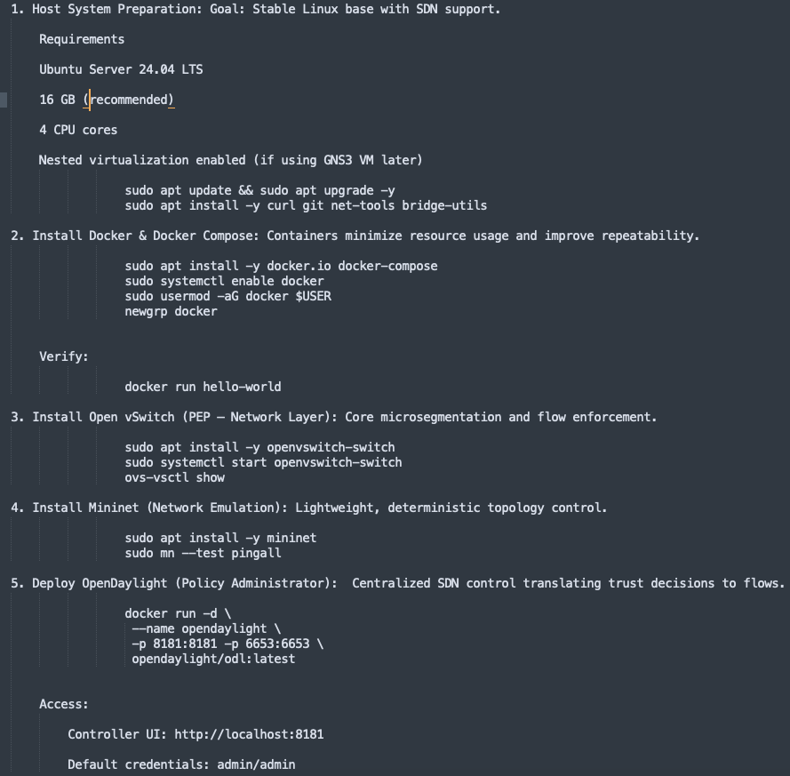

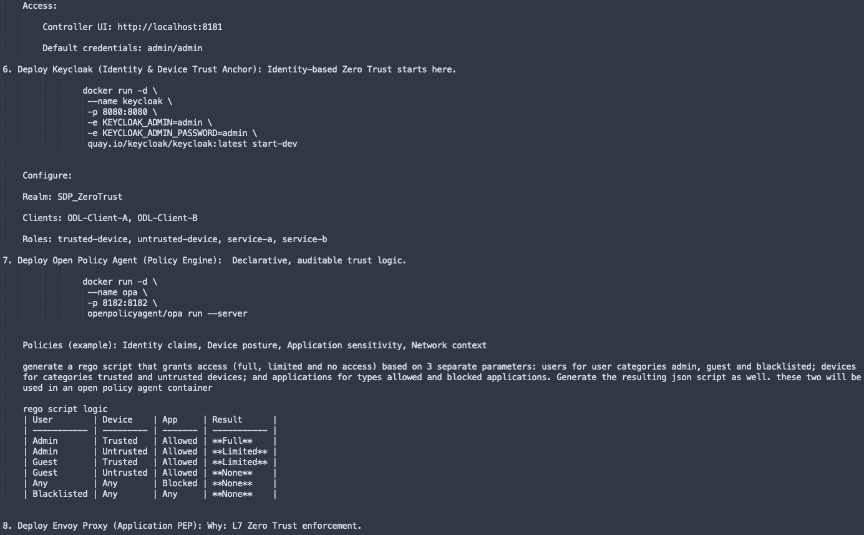

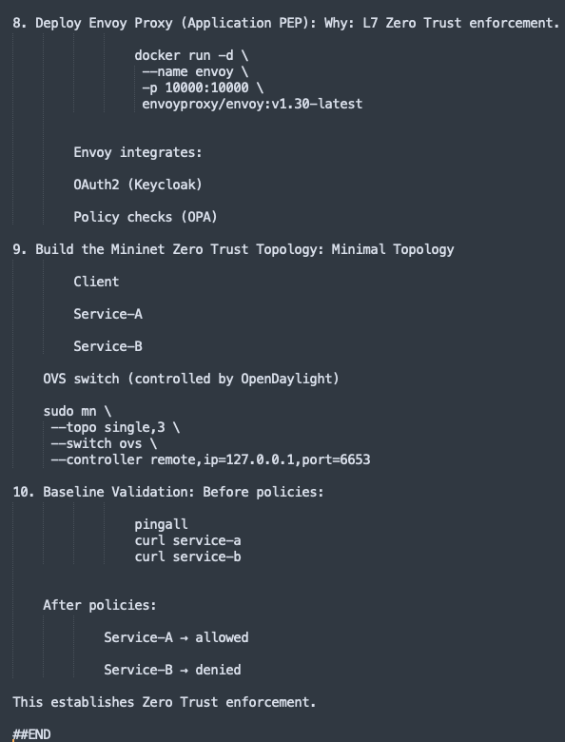

Logic Flows
The logic flows were based on basic principles of zero trusts such as least privilege, continuos authentication and authorization as separate processes and assessment of all communciations and resources within heterogenous networks. The logical flows have been mapped to funadamental principles of zero trust architecture. They include:

Logical Flows
- Default → No access
- Is user blacklisted? → Deny
- Calculate aggregate trust
- Is user admin AND trust ≥ 0.75? → Full access
- Is trust ≥ 0.45? → Limited access

NIST Core Zero trust Principles
- Subject and Device Authentication
- Least privillege and per-session authorization
- Dynamic Access policy
- Fine grained authorization and sgmentation of access
- Continuous Reource Monitoring
- Continuous

TestCase Description
This describes the experiments setup to evaluate incremental policies for zero trust enforcement in heterogenous enterprise environements. The policies are sequentiaally incremental and consider improvements from a single domain criteria based trust decision to dynamic, multi-domain and contextual score based trst decisions with tempral decay to ensure the history of transactions is consdered albeit with waning effect as time elapses.

Baseline
No policy, All services and containers can accees and reach each other. This considers the testbed setup before any policies are defined and flows monitored and evaluated

TestCase 1: Single Domain Criteria based Evaluation
This tescase acts as the fist layer or access decision evaluation. It restricts access based on one domain criteria such as an allowed or blacklisted user, allowed or blocked services and trusted or untrusted devices

TestCase 2: Multidomain Evaluation
This testcase addresses scenarios where users have Enterprise Owned Devices and controlled apps(Uknowned user;device known; apps mostly trusted) or user owned devices with applications that have nt been fingerprinted. It considers permutations across multiple domains based on clear deny-first semantics and easy to extend by adding risk scores, time-based rules and dynamic trust calculations. It can also be tested and measured against frameworks such as MITRE ATT&CK conditions for enetrrprise envriroments. Access decisions include clear grant/reject status with detailed reasons for decisions, especially the decision calculation. The flexibilty of policies is also considered as trusted devices can connect from anywhere; Untrusted devices restricted to local network; Admins can access blocked applications. The tescase policy therefore follows the principle of least privilege and provides clear audit trails for access decisions making the deterministic and auditable.

Testcase 3: Multi-domain with Static trust scores and contextual weights for domains
This testcase extends dynamic policies from labels to numeric trust scores. The motivation is to transition to values that can represent trust as a continuum. Binary trust labels (trusted / untrusted) are overly simplistic for heterogenous networks enforcing Zero Trust architectures. Modern Zero Trust architectures treat trust as continuous and dynamic, influenced by posture, behavior, and context. This testcase thus considers trust score inputs based contexts of the domains defined in testcase 2 and weights based on the importance of each domain per scenario. These include: User trust scores based on identity assurance, roles and transaction history; Device trust score such as Trusted (Enterprise owned compared to BYOD),patch levels, EDR-compliance and Application risk score based on Allowed services, criticality and exposure. This implementation aligns with continuous trust evaluation, a core principle of Zero Trust (NIST SP 800-207). By replacing static labels with weighted trust aggregation, authorization becomes adaptive rather than declarative.The weighted sum model enables dynamicity and policy tunability and continuous analysis of trust score changes during experimentation. Additionally, it provides a bridge between rule-based and probabilistic authorization. This design is especially suitable for research testbeds, where trust weighting can be empirically optimized using traffic logs or attack simulations.

Testcase 4: Proposed Contextual Trust Weighting for Enterprise relevant Zero trust Facets Data(),Device(), Application/Service(), Network()
This testcase considers facets of zero trust selected in section (4.8) that are most relevant in heterogenous enterprise networks. The testcase is a direct extension of testcase 2and 3 based on the propositions of this work. It considers dynamic weighting of four facets each considering 3 parameters for trust determination. These include the data facet, focusing on the resource being acessed, the device and application facets which evaluate the device posture and application footprint respectively as well as the network facet which considers the network on which an access request originates and whether its trusted or not. This test enforces hierarchical multidomain integration and evaluation where blacklisted users are immediately rejected while verified users with some level of access are evaluated based on the originating network, the device posture, the application requesting access. Multidomain-Domain Integration permutations include: data domain (valid/invalid); Application domain (Allowed/Blocked); Network domain (Remote/Local) ; Device domain (Trusted/Untrusted). The trust score is based in dynamic weighting of the four facets and the score is further fuswd based on weighted belief fusion. Metadata availability is used to determine belief and disbelief as probabilistic values while uncertaity is modeled based on absence of metadata. The base value is set at 0.4 to esnure that the default decision in the absence of metadata defaults to denial of access based on the threhold matrix shown in table 8.1. Identicle to testcase 2, Access decisions include clear grant/reject status with detailed reasons for decisions, especially the decision calculation. The flexibilty of policies is also considered as trusted devices can connect from anywhere; Untrusted devices restricted to local network; Admins can access blocked applications. The tescase policy therefore follows the principle of least privilege and provides clear audit trails for access decisions making the deterministic and auditable.

Testcase 5: Trust weighting with temporal decay
This testcase is an extention of testcase 5 and performs contextual weighting of the four facets and continuously decays trust across time. This introduces both short term and long term memory. The metadata is evaluated against a time session of 30min whichinfluences the short term weight while historical data like last untrusted transactions are reviewed after 48 hours. This was determined based on the best practices shown in table 8.3. A summary of all the testcase is presented in Table 8.1

Testcase | Focus | Description
Baseline | Clean testbed, No policies | Garnt/deny access based on one domain criteria: Allowed service, allowed user, allowed device
Testcase 1 | Single Criteria policies | Grant or deny decisions based on single criteria such as Allowed_user/Blocked_user, allowed service/blocked service
Testcase 2 | Multi-domain criteria policies | Hierarchical multi-domain access descisions in Enterprise networks (Uknowned user;device known; apps mostly trusted)
Testcase 3 | Statically weighted multidomain policy (with temperal decay) | Statically weight domains based on resource access scenarios
Testcase 4 | Multidomain Contextually weighted trust determination(dynamic weighting and weighted belief fusion) | Multidomain Contextually weighted trust determination
Testcase 5 | Multidomain Contextually weighted trust determination with temporal decay | Dynamic and contextual weighting and fusion decisions for access policies with temporal decay in trust

Host System Preparation
Zero Trust research demands deterministic environments free from uncontrolled variables. Ubuntu 24.04 LTS provides Long-Term Support (LTS) stability with a 10-year security maintenance commitment, essential for longitudinal studies. The host systems was prepared by minimizing unnecessary services that could introduce attack vectors or measurement noise.

Implementation Details
It was provisioned using Ubuntu 24.04 LTS, selected for its long-term stability, kernel maturity, and compatibility with SDN and container orchestration frameworks for hybrid physical-virtual topologies. This ensures temporal consistency thriugh kernel and library stability across multi-year research cycles. The minimal installation also reduces side-channel possibilities and ensures Reproducibility and peer validation of results. The host operating system constitutes the trusted computing base (TCB) of the entire experimental platform. Any instability or misconfiguration at this layer undermines higher-level security guarantees. Ubuntu LTS minimizes kernel churn and driver regressions, ensuring consistent Open vSwitch and Docker behavior across experiments.This allows for meaningful comparison with related Zero Trust testbeds reported in the literature. The idle resource consumption before adding components was also measured aand evaluated as shown in Figure X.

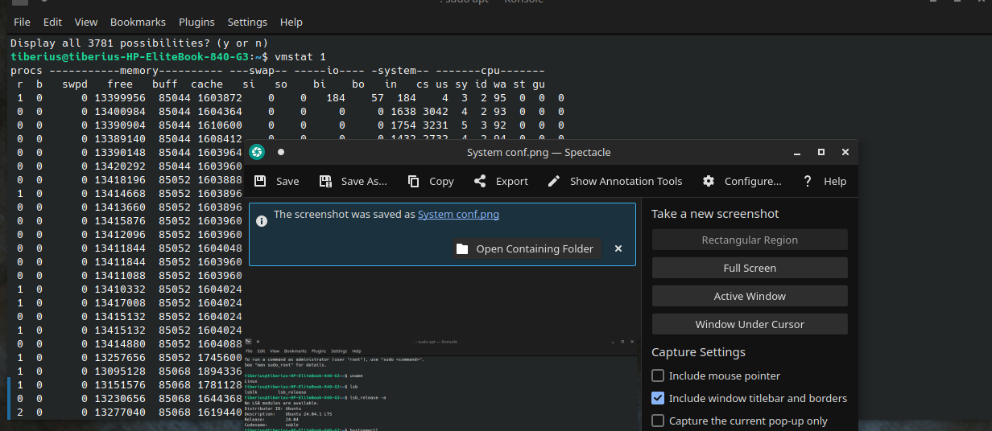

System requirements:
System Domain | values | Description
Memory | 16 GB recommended
Processor | 2.4Ghz, 4 CPU cores
Virtualization | Intel® Virtualization Technology (Intel VT-x) | Nested virtualization enabled (for optional GNS3 VM integration)

Utilities and Libraries Installation
This was done to provision the Linux environment into a machine capable of network manipulation, API interaction, and version control. This is because a fresh Ubuntu server is blind to the requirements of SDN emulation. It does not know how to bridge virtual adapters, it does not know how to pull code from GitHub, and it does not have the tools to easily view routing tables in the format most emulation software expects. By executing this, the necessary foundation is laid before installing core virtualization, networking, PEP, PAP and PDP providers like Docker, OVS, and Mininet.

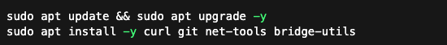
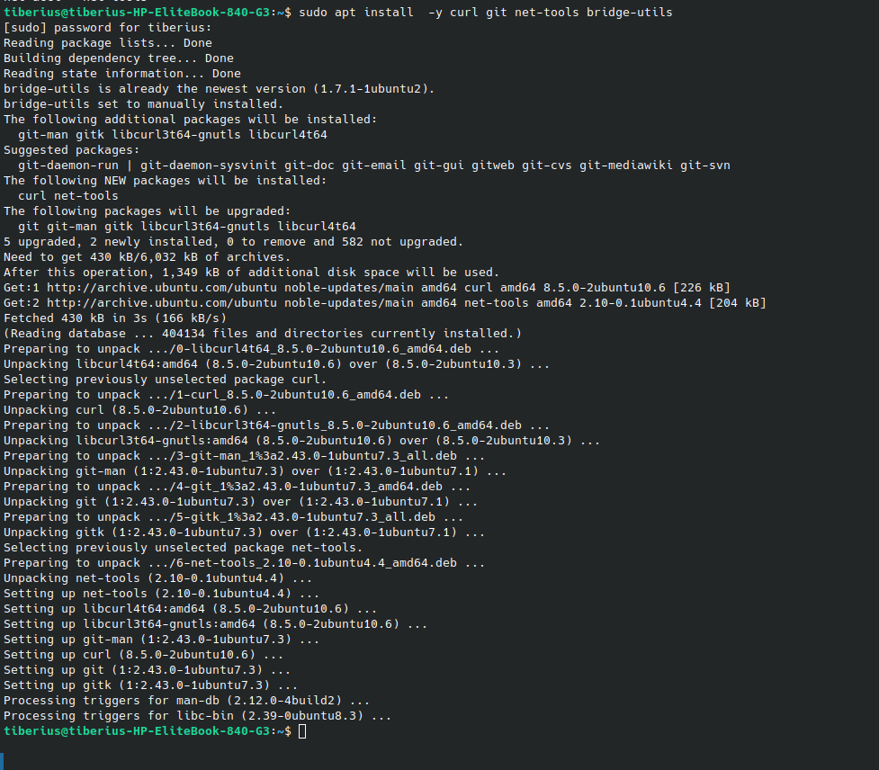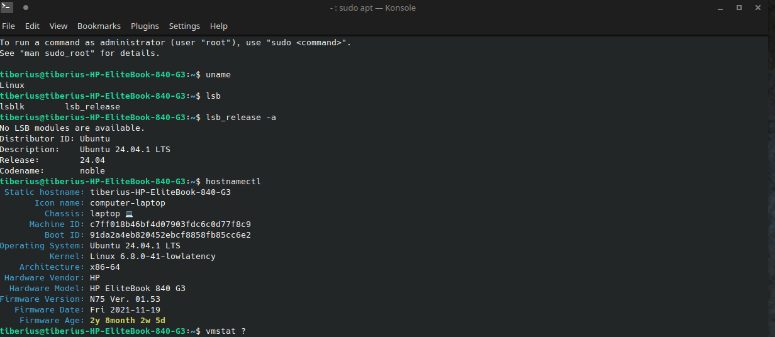

Container and Virtualiazation Runtime: Docker and Docker Compose
Containerization was adopted to ensure isolation, repeatability, and rapid reconfiguration of testbed components. Containers provide process-level isolation without full virtualization overhead, enabling high-density experimental topologies. Additionally, containerization Eliminates configuration drift, controls fault injection and supports reusability of code and configurations in experimentation. It also mirror enterprise deployments that use containerized microservices. Docker enables each Zero Trust component to operate as an independently versioned trust domain, aligning with modern cloud-native security architectures. The Docker's layered filesystem facilitates:Version Control for Experiments, precise CPU and memory Resource Accounting and network Namespace Isolation.
This process was considered to provide a more secure and trusted computing base since containers default capabilites adopta a least privilege approach with little to no container escape possibilities despite the evolving threats targeting docker and other container hypervisors. While most containers can be ephemeral in nature, these containers were set-up and run as background daemons to esnure that the states are easily managed and the hosts can easily communicate with each other. This made the testbed more suitable for the multinode research and representation required for testing of the custom dynamic and context aware trust algorithm Docker setup and verification processes are illustrated in figures X and Y
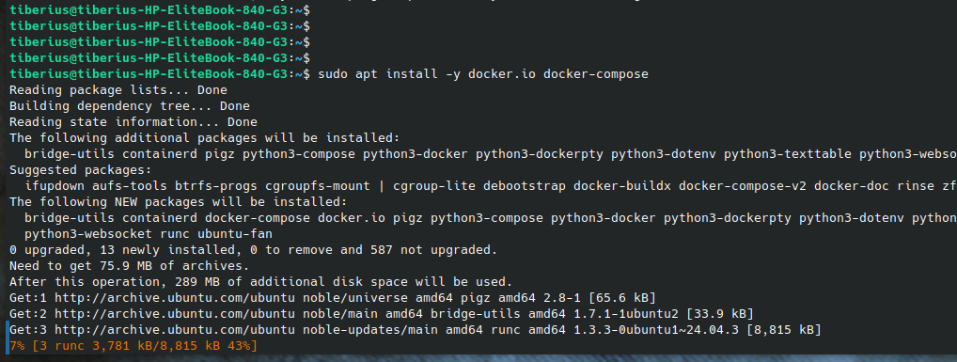
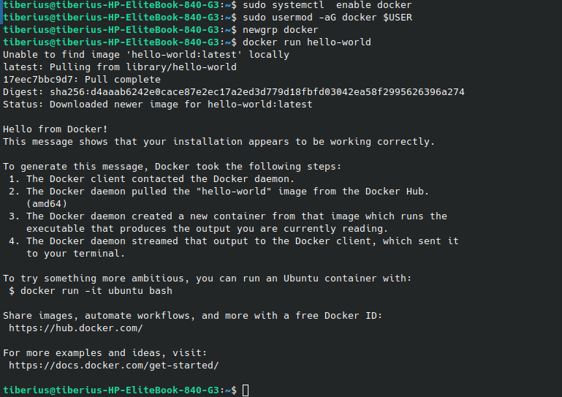

Open vSwitch: Network-Layer Policy Enforcement Point
Open vSwitch (OVS) was deployed as the network-layer PEP, enabling fine-grained flow-based enforcement. OVS replaces static perimeter devices with programmable microsegmentation, a foundational Zero Trust principle. By delegating forwarding decisions to a centralized SDN controller, the network becomes policy-driven rather than topology-driven. It evaluates decisions at the network layer through Flow Tables to Match-action rules derived from higher-level policies and Statistics Collection through Per-flow counters for behavioral analysis. It allows for protocol independence by decoupling from specific L2/L3/L4 protocol implementations. OVS allows precise measurement of Flow installation latency, Enforcement granularity and Lateral movement containment. This is critical in assessing the less evaluated lateral escalation by attackers focusing on aggregation and inference data attacks (D'Silva, 2023). OVS installation and setup is whon in figure X
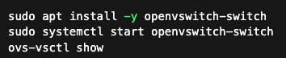
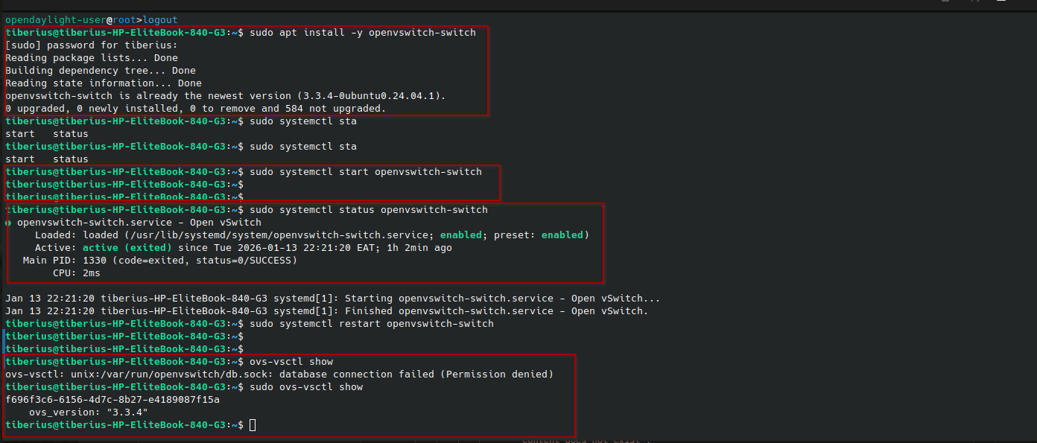

Mininet: Network Emulation Layer
Mininet was used to emulate a controlled network topology using lightweight Linux namespaces.
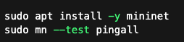
Mininet provides deterministic and repeatable network conditions, which are critical for controlled security experiments. Unlike pure simulation, Mininet executes real protocol stacks, striking a balance between realism and experimental control. This makes Mininet particularly suitable for evaluating Zero Trust enforcement effectiveness without introducing unnecessary environmental noise. Mininet also allows us to map individual services, clients and/or users into indivdual hosts such that their bahvior follows that of hosts communicating within the environment. With Karaf (opendaylight) acting as the policy administrtor, opebflow rules can be applied such that openvswitch grants or dnies access toservice and/or client. Mininet allows for automation of the toplogy basedon python scripts which align and syncronize with he docker community engine, its composer and the defiition of custompolicies on Envoy and OpenPolicyAgent. The installation and version is shown in FIGURE 8.5 and an example script is shown in figure 8.6
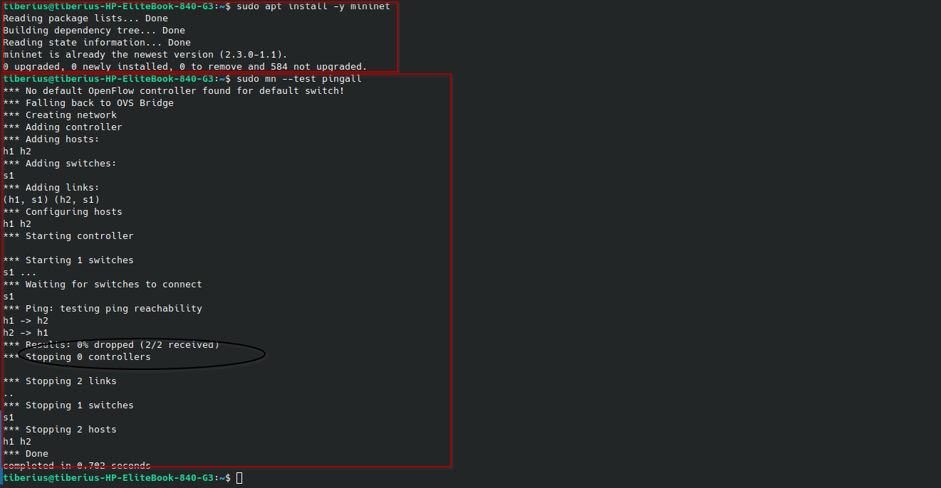
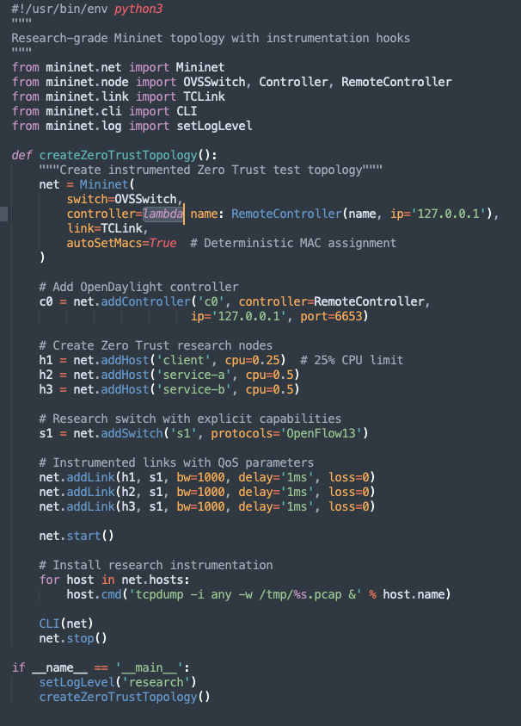

OpenDaylight: Policy Administration Point
OpenDaylight (ODL) was deployed as the SDN controller responsible for translating trust decisions into OpenFlow rules. The version setup is 21.2 and is provided as package named karaf that allows for a web API through port 8181, ssh access through port 8101 and openflow access through ports 6653 and 6633 for versions 1 and 1.3 respectively. The testbed works on verion 1.3 which is stable and supports multiflow tables, metering and possible controller failovers. While opendaylight is primarily a PDP, it is used to enforce custom rules based on L2/L3/L4 or L7 conditions and thresholds. It therefore acts as the Policy Administration Point (PAP) in the Zero Trust architecture. Its role is not to decide trust, but to operationalize trust decisions produced elsewhere. This separation ensures architectural clarity and prevents policy logic from being embedded in the network layer. This decoupling allows independent evaluation of decision quality versus enforcement efficiency. Opendaylight REST API features as well as network flows for openflow protocol and AAA services were also installed to support network flow rules. The container deployment, configurations, features installed and the available features list are illustrated in Figures 8.7 through to 8.10
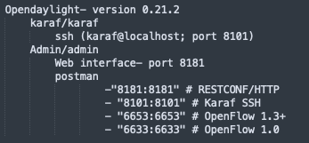
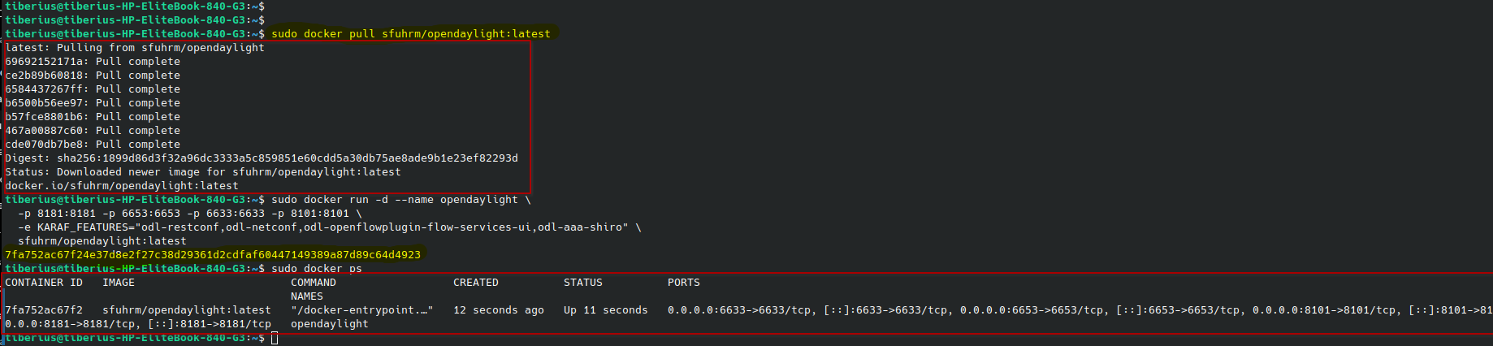
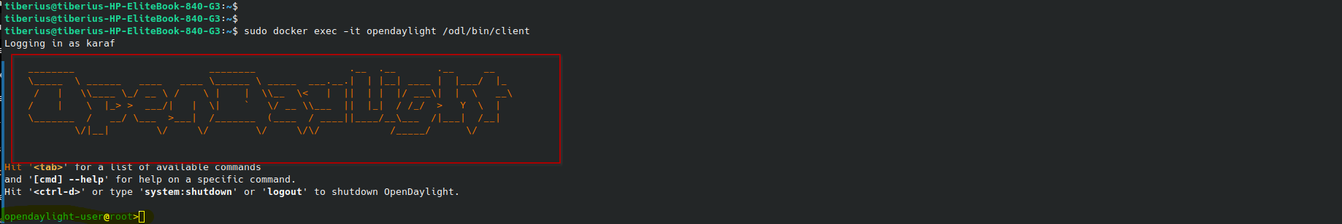
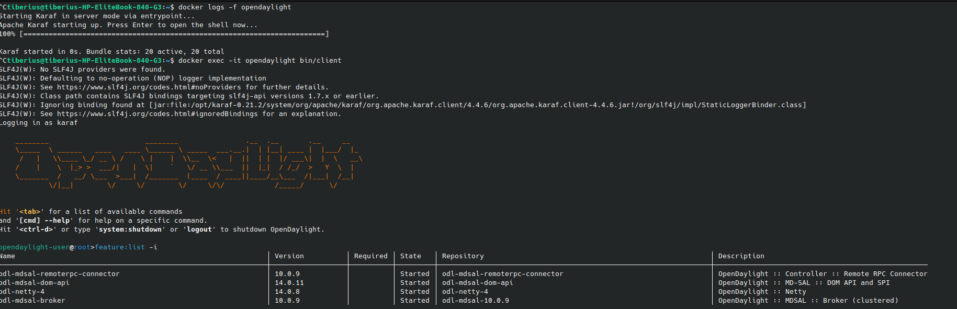

Keycloak: Identity and Device Trust Anchor
Implementation Details
Keycloak was deployed to provide identity, authentication, and device trust attributes. Identities are the primary trust primitive in trust estimation in Zero Trust architectures. Consequently, Keycloak provides a standards-based identify proofing based on OAuth2/OIDC. It also provides a Fine-grained role and claim issuance with extensibility for device posture signals and values. From a research perspective, Keycloak enables attribute-based trust propagation, allowing identity claims to influence network and application-layer decisions. This is essential for evaluating identity-centric security models against legacy perimeter-based designs. The configurations were performed as follows as shown in figure 8.10:

Configuration
- Realm: SDP_ZeroTrust
- Clients: ODL-Client-A, ODL-Client-B
- Roles:trusted-device; untrusted-device; service-a,service-b

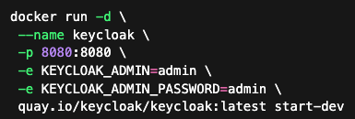
Zero Trust architectures place identity at the center of access control. Keycloak provides cryptographically verifiable claims that propagate trust context across layers. In this testbed, identity and device posture serve as primary trust signals for downstream policy evaluation. This approach reflects contemporary enterprise practice and enables attribute-based access control (ABAC) experimentation.

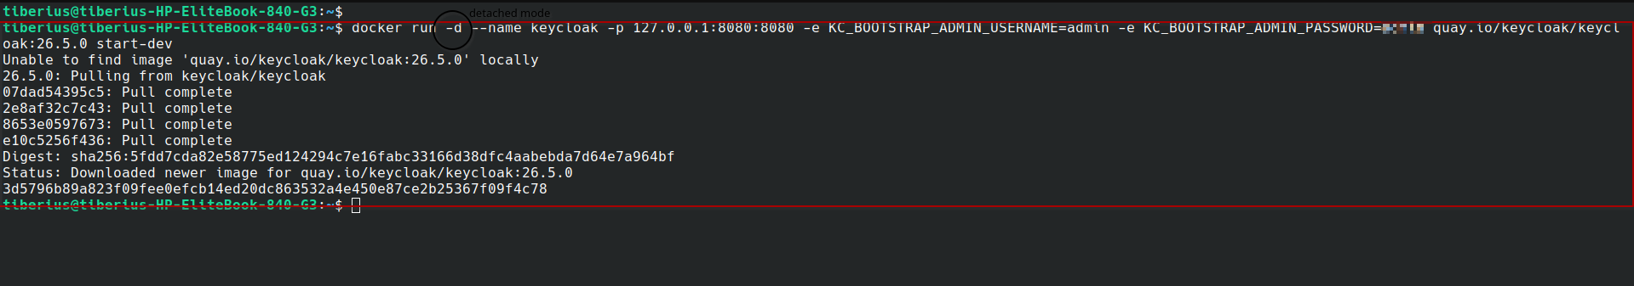

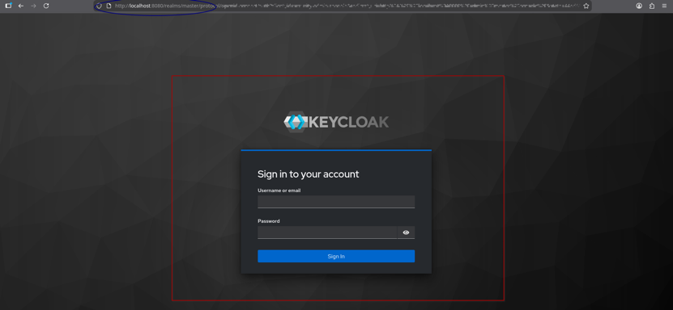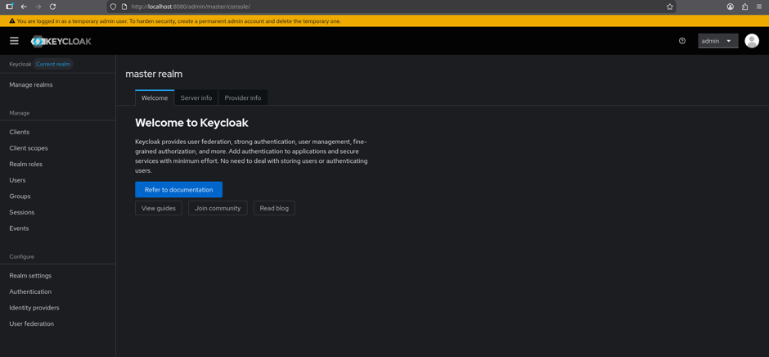

Open Policy Agent: Policy Decision Point
OpenPolicyAgent was deployed as the the PDP where polcies are defined based on what is allowed within the network environemnt. OPA enables policy-as-code, transforming trust logic into a formally analyzable artifact. This makes access control auditable, version-controlled and testable. These are defined as rego files where thetrust algorithm is defined as code logic to guide access control decisions. Rego policies function as executable security hypotheses, allowing empirical validation of Zero Trust assumptions. Integrating OPA with service-level proxies enforces policy outside the application resulting in reduced attack surface, improved policy consistency and centralized auditability. This approach supports Zero Trust microsegmentation, where each service request is independently authorized, even within the same network zone. The proxy-OPA pattern enables repeatable experiments on authorization latency, scalability, and failure modes.

Implementation Details
OPA was deployed as the centralized PDP for identity claims, data descriptio, device posture, application sensitivity, network context. The container was deployed as an OPA container running on port 8182. While the default port is 8181, this conflicts with the default REST port for the ODL container. The setup was deployed such that all addresses with the port number establsh a socket that connects to the service. This was an operational decision for easier interworking withother containers dspite the resutingsecurity risks (0.0.0.0:8182). The version of OPA is(opa:1.12.2-istio-1). Custom policies as Rego and Json files were used to define the logic and represent input data simulating contextual heterogenous network metadata. The policies were incrementally built from single criteria policies (user type, auth-type,application protocol) to Multi-criteria polcies based on the four facets considered and subsequently improved to contextual, multi-domain weighted and fused trust policies as per the testcases defined.
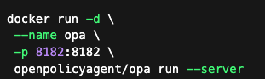

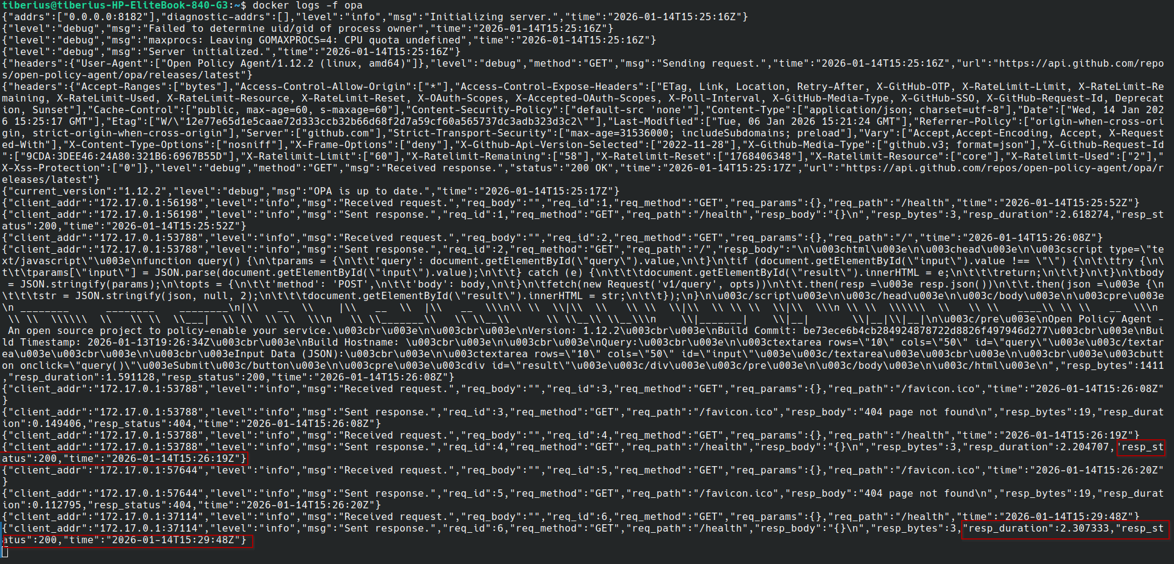
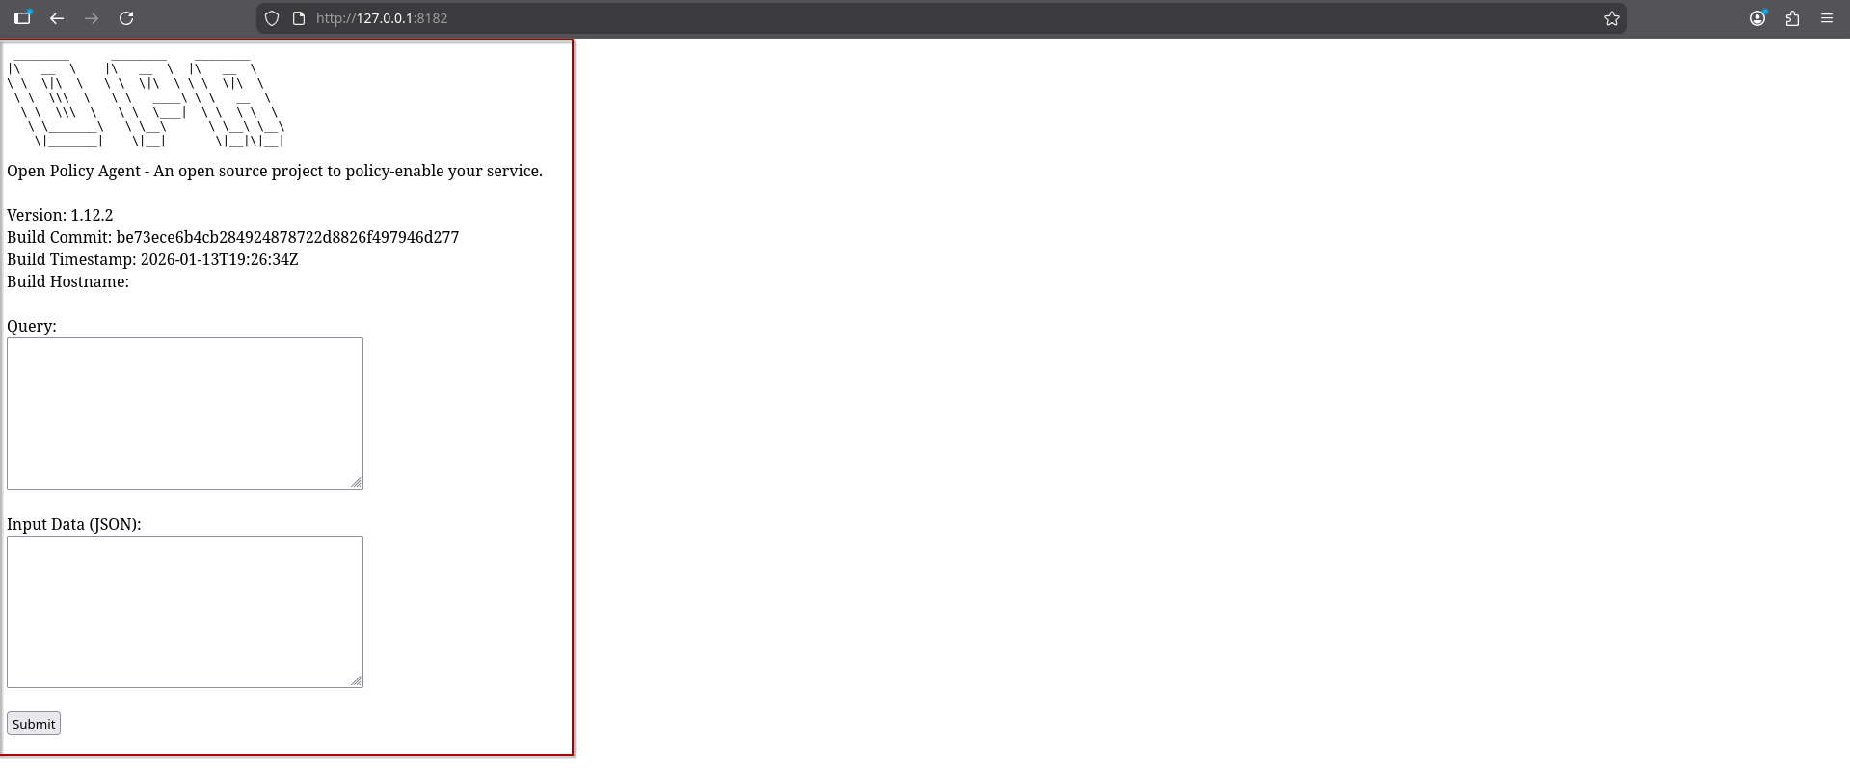
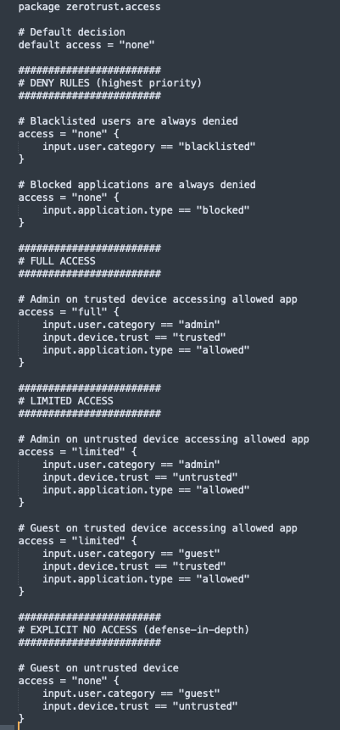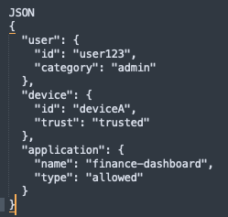

Envoy Proxy: Application-Layer PEP
Envoy was deployed as the application level PEP and integrates OAuth2 authentication via Keycloak and Authorization checks via OPA. Network-layer controls alone cannot prevent application-level misuse. Envoy enforces per-request authorization, ensuring that every API call is explicitly validated against policy. This closes the gap between network microsegmentation and application security, a critical requirement for Zero Trust completeness. This transformation elevates the policy from RBAC-inspired rules to full ABAC, enabling Fine-grained decisions, Context awareness and Policy scalability. ABAC is particularly suited for Zero Trust because it avoids role explosion and supports dynamic attributes, such as behavioral trust scores and real-time risk signals. It also enables comparative analysis against RBAC and capability-based models, offering measurable advantages in expressiveness and security posture.

Implementation Details
Envoy was deployed to enforce authorization at Layer 7. Envoy implements the Application PEP through epresents a modular, ordered processing pipeline through which network traffic is evaluated, transformed, and either forwarded or rejected. This is realized through layered network and HTTP filters, each responsible for a discrete concern such as authentication, authorization, rate limiting, or telemetry. This architecture aligns with the principle of progressive trust evaluation, where no single component is implicitly trusted and every request is continuously inspected as it traverses the data plane. It also provides a lightweight, sandboxed execution environment that allows custom logic to run safely inside the data plane resulting in dynamic policy execution without recompiling or redeploying the proxy. The proxy level metrics and logs also provide additional observability and feedback for policy tweaks od deployment enhancements.
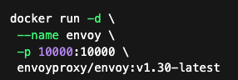

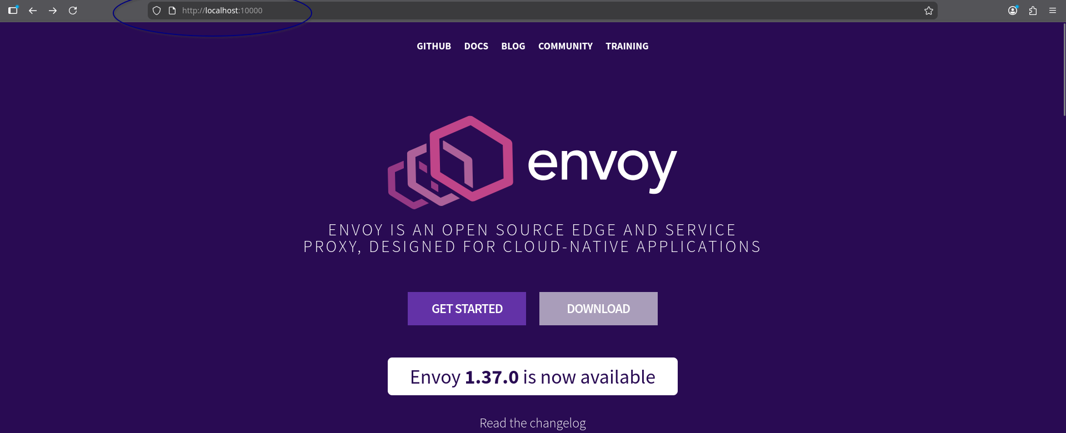

Mininet Zero Trust Topology Construction
The minimal topology reduces confounding variables while still capturing essential Zero Trust dynamics. This design choice supports controlled experimentation, enabling clear attribution of observed effects to policy enforcement rather than network complexity.

Implementation Details
A minimal topology was constructed based on 2 hosts (Service-A and Service-B) and later extnded tobased on 6 hosts and a Single OVS switch (controlled by OpenDaylight). The hosts are ODL_Client-A, ODL_Client-B, Trusted-Device, Untrsted-device, Service-A and Service-B
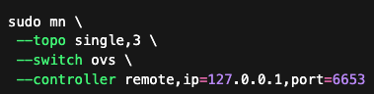
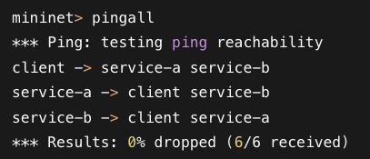

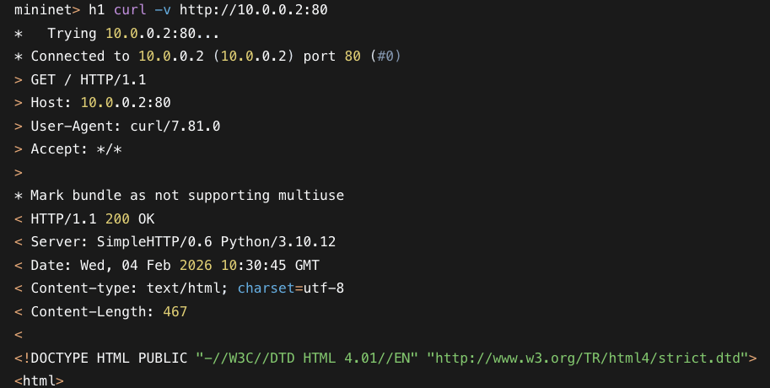
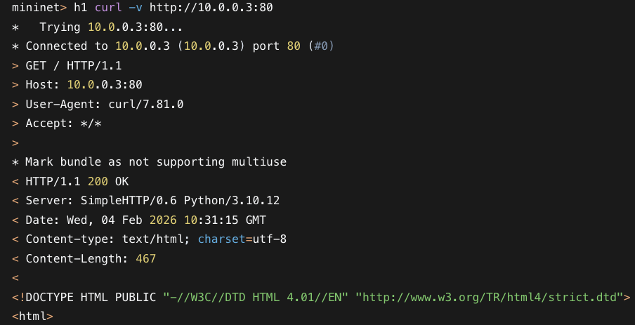
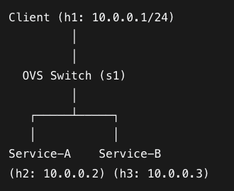

Before policy enforcement: all services could ing each other and access the switch. Testing accessibility using curl on postman also returned a 200-OK. This indicated that both services, represented as hosts on mininet could access the infrastructure. On enforcement a single criteria policy based on allowed services(Service-A) and blocked services (service-B), the result was:
After policy enforcement:Service-A → Allowed and Service-B → Denied

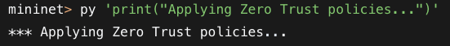
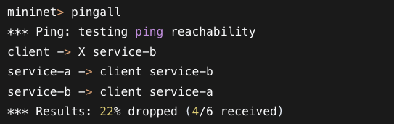

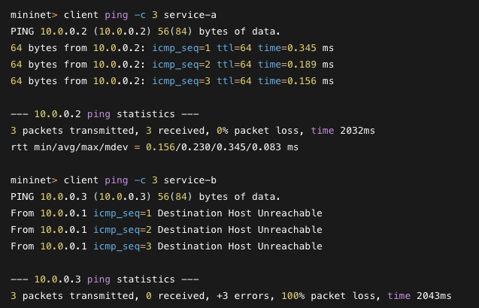
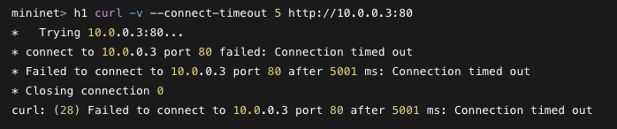
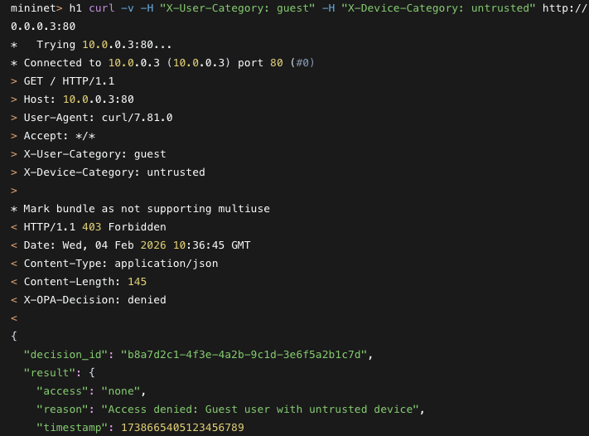
This validation confirms the elimination of implicit trust. The observed behavior demonstrates that access decisions are now policy-driven, identity-aware, and context-sensitive, satisfying the fundamental goals of Zero Trust. This baseline establishes a reference point for subsequent testcases, where dynamic, multi-domain trust extensions are introduced and evaluated as illustrated in Figure 8.7
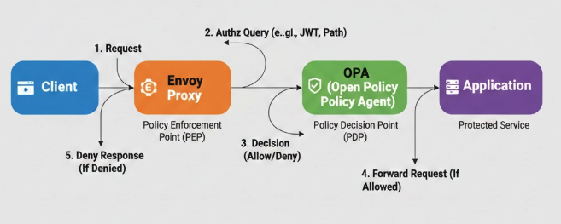
This chapter detailed the implementation of a reproducible Zero Trust baseline testbed, integrating identity, policy, network, and application enforcement layers. The modular architecture ensures experimental rigor and provides a foundation for advanced trust modeling and adversarial evaluation presented in subsequent chapters.

Evaluation Framework
This sets out a set of reference tables and matrices based on industry practice, best practice or rules of thumb for heterogenous enterprise environments.
Table 8.4 shows the base score mapping matrix that determines trust scores for different contexts within enterprise environments. The base scores are Configuration Parameters (Inputs), not Calculations (Outputs) set by the System Designer (or Administrator) to model a specific environment. They range from very high trust levels (0.9-1.0) as the highest level to untrusted environemnts(less that 0.5) as the lowest tier. The lowest tier primarily indicates that ignorance(lack of metadata or uncertainty) exceeds the leve of information required to make decision. This forms the basis for assigning trust values to different scenarios
Trust Score (Base Score) Legend
Range | Trust Level | Description | Example Contexts
0.90 - 1.00 | Critical / High | Managed & Compliant. Fully authenticated, patch-compliant, encrypted, and monitored. | Corporate LAN, Company-Issued Laptop, Admin User.
0.70 - 0.89 | High / Medium | Known but Flexible. Authenticated but potentially unmanaged or roaming. | Remote VPN, Vendor Laptop (with Agent), Standard User.
0.50 - 0.69 | Medium / Low | Unknown / Gray. Authenticated user on unknown device or network. | BYOD (Mobile), Coffee Shop Wi-Fi, Guest Network.
< 0.50 | Untrusted | Hostile / Malicious. Known bad reputation, active anomalies, or policy violation. | Tor Exit Node, Jailbroken Device, Failed Login.
A clear distiction between very high and high trust (Gold vs. Silver levels) such as Distinction between 0.95 and 0.90 scores comes from minute differences reflected ub Assurance Levels (NIST 800-63B). Very High trust represents contexts with highly restricted, strictly managed assets with requirements such as enterprise owned device with hardware level authentication (Device Certificate + Biometric + Geolocation + No Vulnerabilities and privileged user access). High trust (silver level) represents standard corprte access with requirements such as a healthy device posture with mFA(Password + MFA + Healthy Device and a verified regular user). The silver levels haveslightly lower trust levels becaise most resources access requests are less "hardware-bound" than device-tunnel sessions, slightly increasing risk surface such as through session cookie theft.
The rationale for the matrix is alignment with CVSS matrix and Nist confidence levels cybersecurity frameworks to ensure interoperability. The CVSS matrix allows the model to ingest vulnerability data directly into the App/Device domain scores while NIST defines that access is granted not just on "Identity" but on the "Confidence" in that identity's current state.Variance-based Weighting directly implements a "measure of the distinctiveness and freshness" of the data such that high Variance results in Low Confidence (weights).

Table 8.5 shows the reference matrix for signal and metadata variance based on contexts
Stability (Variance) Legend
Value | Stability | Description | Example Contexts
0.01 - 0.02 | Stable | Fixed / Wired. Physical connection or static location. | Ethernet, Desktop PC, Server.
0.03 - 0.05 | Variable | Wireless / Roaming. Normal fluctuation due to RF or human movement. | Office Wi-Fi, 4G/5G, Laptop moving between APs.
0.10 - 0.20 | Unstable | Weak Signal / Congested. High packet loss or latency. | Public Wi-Fi (Crowded), Edge of Cell Tower.
> 0.25 | Chaotic | Attack / Failure. Random behavior indicative of spoofing or DoS. | Man-in-the-Middle Attack, Hardware Failure.

Table 8.6 defines the specific numerical ranges used to make access decisions for the Trust Model. The ranges are derived by mapping our [0.0 - 1.0] continuous trust score to 1-0.75-0.45 thresholds in line with Confidence Levels and Trust Tiers defined in authoritative industry frameworks (NIST, Google BeyondCorp, CVSS).
Trust Score (T) | Decision | Industry Equivalent
0.75<T≤1.00 | Full Access | High Confidence (NIST) / Tier 3 (BeyondCorp)
0.45≤T≤0.75 | Limited Access | Moderate Confidence (NIST) / Tier 2 (BeyondCorp)
T<0.45 | No Access | Low Confidence (NIST) / Tier 1 (BeyondCorp)

Full Access (T>0.75) decisions show that an entity is fully authenticated, compliant, and operating in a secure context. It maps to tier 3:"Highly Privileged Access" based on Googles beyondcorp.Devices in this tier possess the highest level of security hardeningand are granted greater privileges for sensitive internal resources. This aligns with the upper quartile of trust, requiring effectively perfect scores in at least 3 of 4 domains (Network, Device, Identity) to achieve. Majority Rule" (0.75) is met such that in a 4-domain system (User, Device, Network, App), if 1 domain fails completely (Score 0.0) and 3 are perfect (1.0), the simple average is 0.75, hence no full access.

Limited Access (0.45<T<=0.75) decisions show an entity is authenticated, but the context carries elevated risk (e.g., BYOD, Public Wi-Fi). It maps to Tier 2: "Basic Access" and allows for more access than untrusted devices, but restricts sensitive infrastructure. It captures the "Middle Ground" where valid credentials exist but environmental factors (Network/Device) drag the average down. It also maps to the inverse of Medium Severity (4.0 - 6.9) in cvss and moderate confidence in NIST. Access to a resource is granted if the calculated trust score surpasses a pre-configured threshold and factors such as device status can affect access decisions
No Access (T<0.45) captures an entity that is unknown, non-compliant, or behaving anomalously. It maps to tier 1: "Untrusted" on Googles beyondcorp and the inverse of High/Critical Severity (7.0 - 10.0) in cvss. Devices in this tier have minimal security hardening and are typically allowed to access only publicly available data. The threshold mathematically implies that Uncertainty (m(Θ)) or Disbelief outweighs Belief. Based on fail safe defaults and belief fusion, you cannot grant access when ignorance dominates knowledge. Coin Toss (0.50 → 0.45) is also met and since a score of 0.50 represents "Unknown" or "Random Chance". The threshold is lowered slightly to 0.45 to account for measurement noise (Variance). If the trust score is less than 45% it is statistically safer to deny access. This also provides a 5% "buffer" for benign jitter before revocation.

Baseline Evaluation: Without any policy Enforcement
This evaluation considers a testbed without any policies. Any user, device and application is allowed to access recources as illustrated by Table 8.3
User | Value Variations | Access Decision
Any(Admin, G) | [Admin, Guest, Blacklisted] | Granted
Device
Any | [trusted Device, Untrusted device] | Granted
Application/Service
Any | [Allowed Service, Blocked Service] | Granted

Testcase 1 Evaluation: Single Criteria Policy
This testcase considers a single domain criteria based access decisions. The decisions are made based onfulfilment of specific criteria within a single domain. These may include user rols, device posture or application profile. This was performed by a rego script enforcing a criterion per domain on User-role, Device-Posture and Application-Profile as shown in Table 8.3. The rego snippet is shown in Figure 8.7

User | Value Variations | Access Decision
User roles | Admin | Granted
 | Guest | Granted
 | Blacklisted | Denied
Device
Device Trust | Trusted Device | Granted
 | Untrusted device | Denied
Application/Service
Application profile | Allowed Service | Granted
 | Blocked Service | Denied

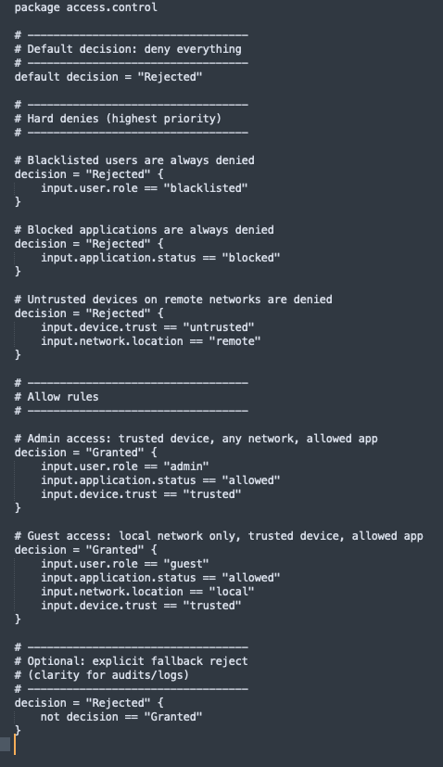

Testcase 2: Hierarchical Multi-domain Policy
This evaluates Multi-Domain/Multi-Faceted Zero trust Evaluation. It includes a Combined Multi-Criteria Evaluation of Access Decisions across multiple domains. It considers user roles, device posture and application profiles. The variations in permutations determine the level of access as Full, Limited or No access as shown in Table 8.4. Variations are als
User | Device | App | Access Decision
Admin | Trusted | Allowed | Full
Admin | Untrusted | Allowed | Limited
Guest | Trusted | Allowed | Limited
Guest | Untrusted | Allowed | None
Any | Any | Blocked | None
Blacklisted | Any | Any | None

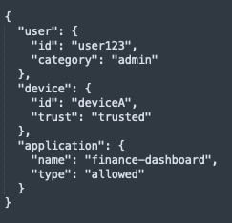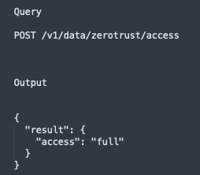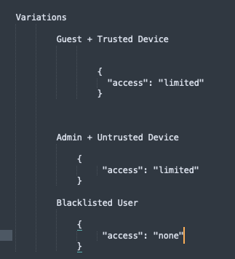

TestCase 3: Multi-Domain with Static Trust Scores and Domain weights
Modern Zero Trust architectures need to treat trust as continuous and dynamic, influenced by posture, behavior, and scenarios that defined context. This means that binary or ternary trust labels such as trusted, semi-trusted and untrusted are overly simplistic to hanndle these contexts especially in heterogenous enterprise neeworks. As such, this tescase looks at weighting trusts values depending on context. The focus is static weighting of different domain areas to determine an eventual trust score that is compared against thresholds that detrmine access levels. This testcase forms a fundamental foundation towards more dynamic and cntextual trust estimation and/or determination. Trust score inputs are defined within quuries and used t calaculae trust based on weights provided in the rego scripts. The eventual trust scores are check against predetermined rresholds for full, limited or no access decisions. This aligns with the multi-criteria, score based continuous trust evaluation principle of Zero Trust. Tunability, and bridging or rule based and probabilistic authorization becomes a critical outcome in this testcase. The rego file snippet, input and output for different subcases within this tescase have been show in figures 8.11 through to 8.15. The explanations for each access decisions that results from the trust determination process is also provided for each sub-case.

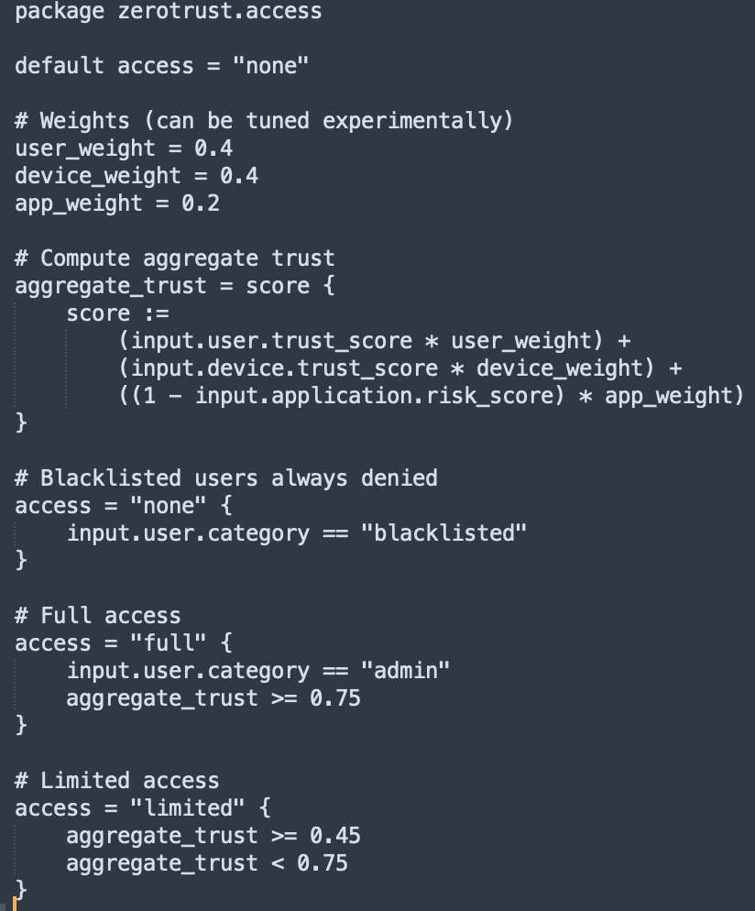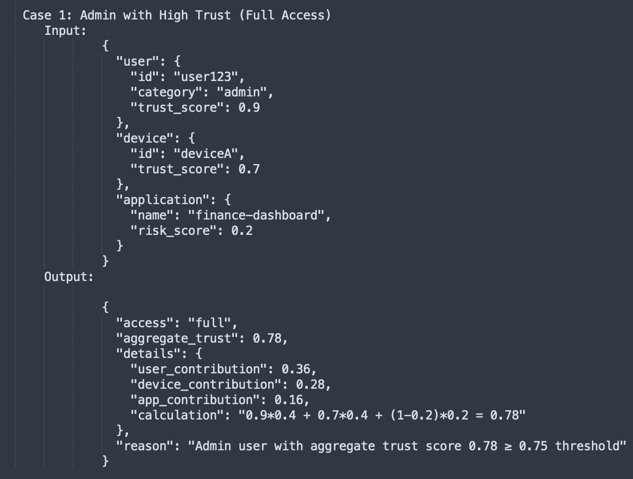

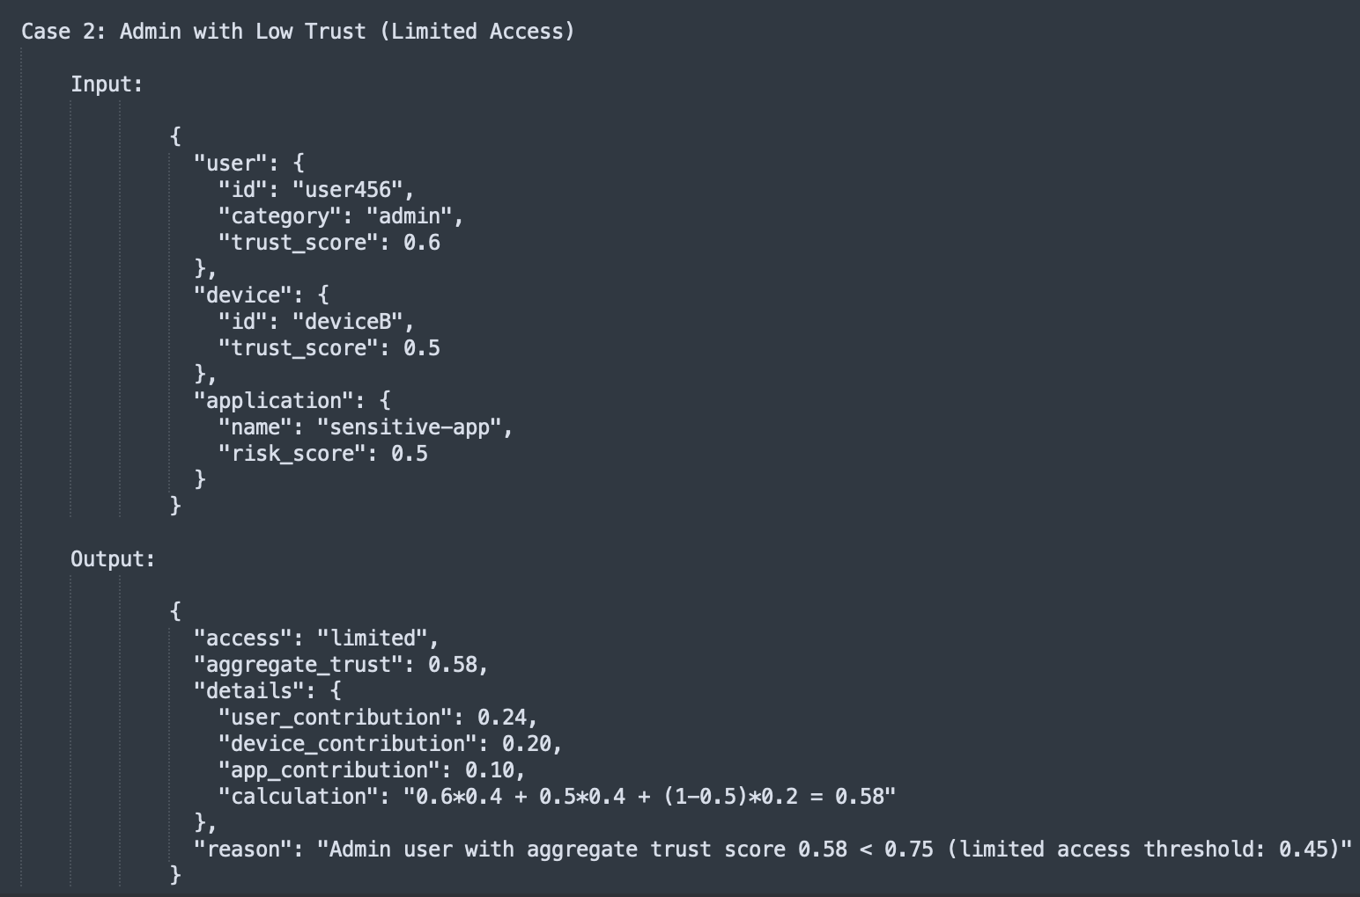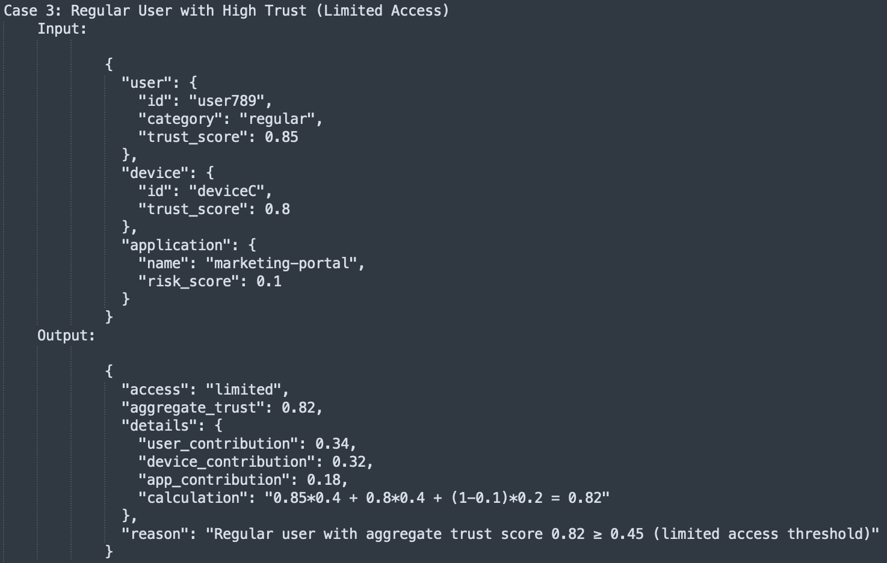

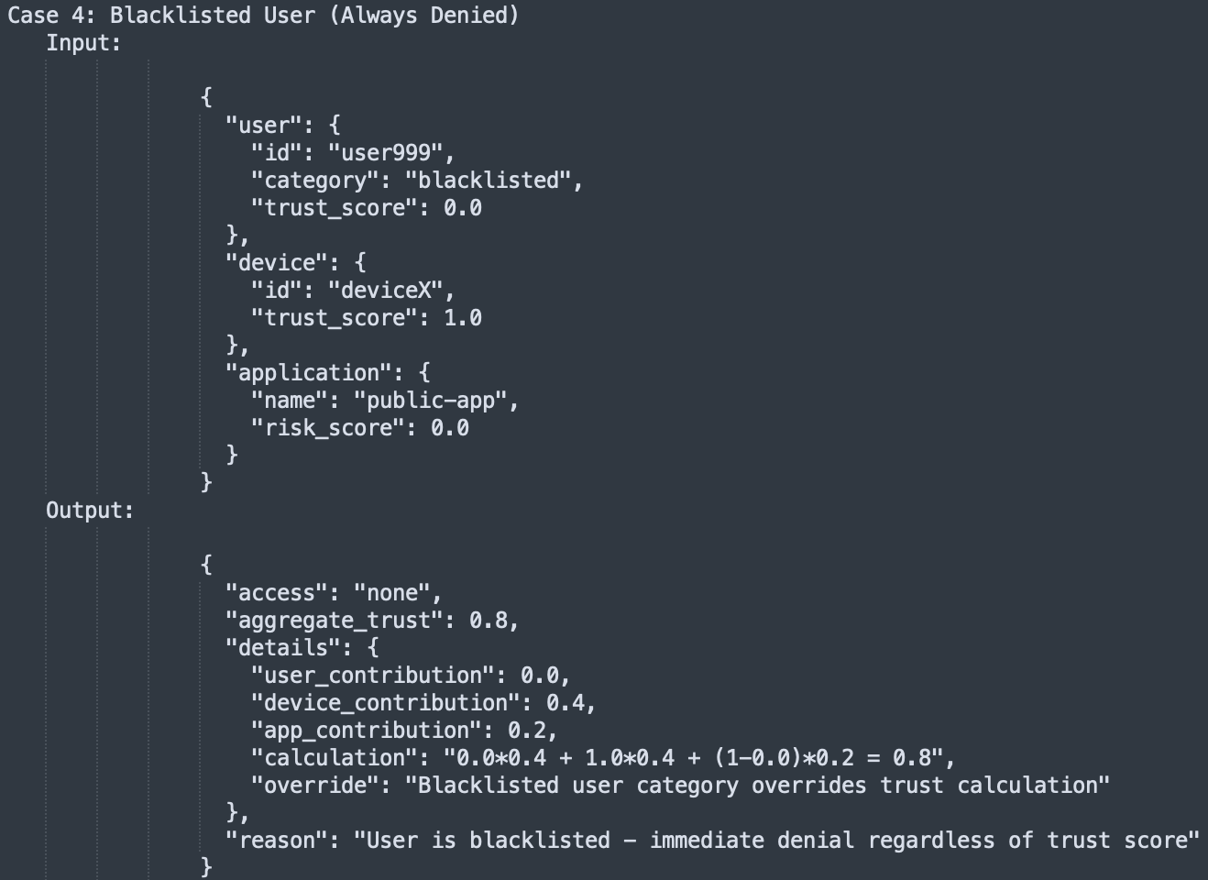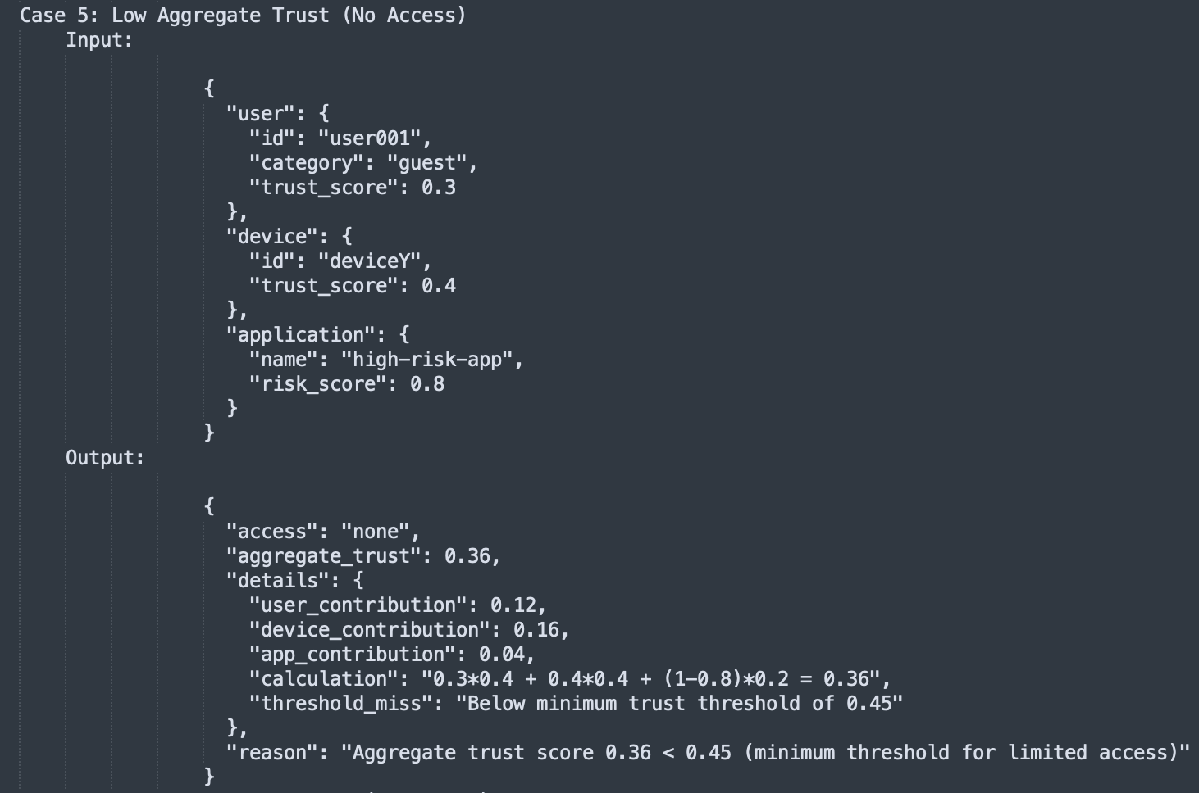

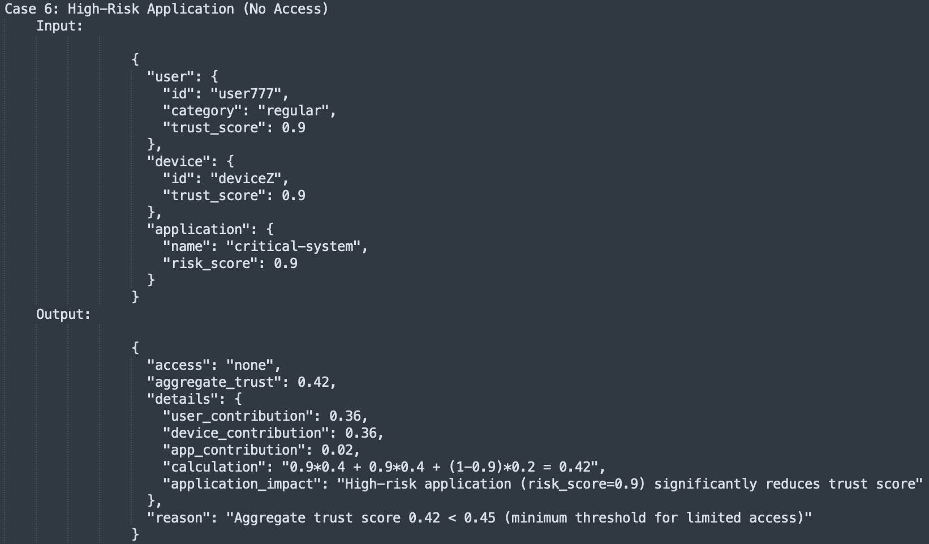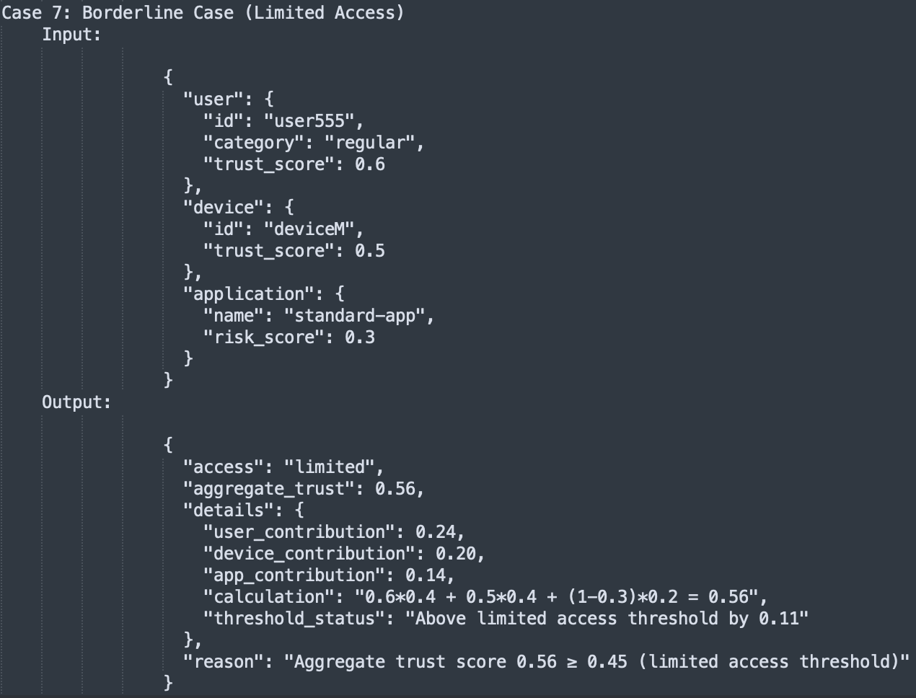

The trust value is estimated as Aggregate Trust of the domain signals and trust weights. Domain Weights used were User (40%), Device (40%) and Application (20%). Application risk was used as a measure of the profile whih is inversely proportional to application trust profile.
Aggregate Trust= (user_trust × 0.4) + (device_trust × 0.4) + ((1 - app_risk) × 0.2)

This denotes a scenario where user identities are critical as well as device identifiers with less importance attached to the application since once the user and the device are identified, the applications are mostly controlled based on the two preceding domains that act as parent domains encompassng the application/service domain. This is identical to scenario 4 in table 8.5 in testcase 5. The summary of the 7 cases of tescase 3 are represented in Table 8.2

Tescase 3 with Temporal Decay
This variation explores how an exponential decay functions transform static trust assessment into more dynamic security postures that reflect operational realities. Traditional Zero Trust implementations largely operate on static trust models where access decisions are based on snapshots of contextual information resulting in limitations such as temporal Insensitivityfor authenticated users, context Staleness especially on device posture, session Inertia where sessions persist beyond their security relevance and a lack of adaptiveness to threat response. The temporal dimension in trust estimation thus consider operational timescales and provide
proportional response mechanisms especially to threats such as Session Hijacking, Device Compromise and Behavioral Anomalies. A rego script implementing an exponential decay fucntion based on a decay constant of 0.01% is used as shown in figure 8.16

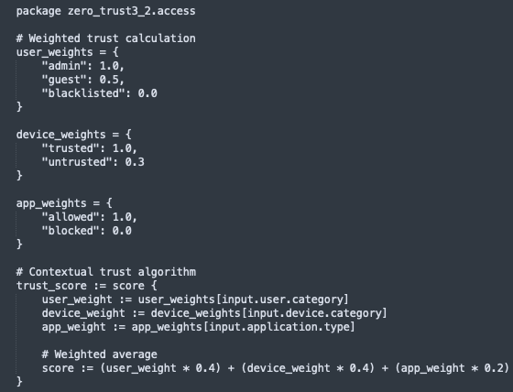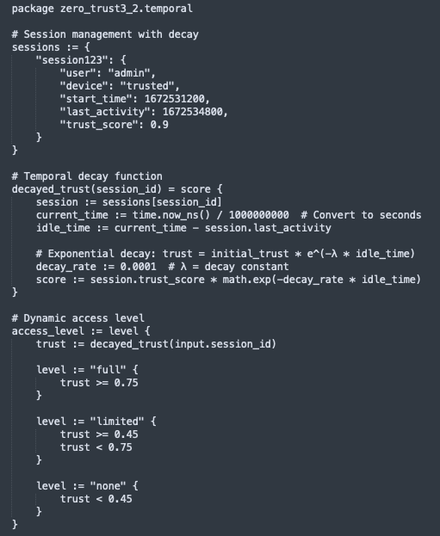

Tescase 3: Test Cases Summary
Test Case | User Category | User Trust | Device Trust | App Risk | Aggregate Trust | Access Level | Key Reason
SC1 | Admin | 0.9 | 0.7 | 0.2 | 0.78 | Full | Admin with trust ≥ 0.75 threshold
SC2 | Admin | 0.6 | 0.5 | 0.5 | 0.58 | Limited | Admin trust < 0.75 but ≥ 0.45
SC3 | Regular | 0.85 | 0.8 | 0.1 | 0.82 | Limited | Non-admin with trust ≥ 0.45
SC4 | Blacklisted | 0.0 | 1.0 | 0.0 | 0.8 | None | Blacklisted user (immediate denial)
SC5 | Guest | 0.3 | 0.4 | 0.8 | 0.36 | None | Trust < 0.45 minimum threshold
SC6 | Regular | 0.9 | 0.9 | 0.9 | 0.42 | None | High-risk app reduces trust below threshold
SC7 | Regular | 0.6 | 0.5 | 0.3 | 0.56 | Limited | Borderline case above 0.45 threshold

Tescase 3:Decision Thresholds Matrix
User Category | Trust Score Range | Access Level | Notes
Blacklisted | Any score | None | Immediate denial regardless of trust
Admin | ≥ 0.75 | Full | Highest privilege level
Admin | 0.45 - 0.74 | Limited | Admin with moderate trust
Admin/Regular/Guest | < 0.45 | None | Below minimum trust threshold
Regular/Guest | ≥ 0.45 | Limited | Standard limited access

Based on the access decision matrix, the Summary testcase 3 access decisions include immediate denial of access for Blacklisted usersand all users with a trust score that is less than 0.45. privileged users with a trust score above 0.75 get full access while all users with a score between 0.45and 0.75 get limited access to resources. Each decision includes detailed breakdowns of the trust calculation and reason for the decision, making it transparent how the decision was reached.
Testcase 3 logic flow
- Absolute Rules:
  - Blacklisted users are always denied (highest priority)
  - Admin status provides privilege but still requires minimum trust
- Trust Thresholds:
  - Full Access: ≥ 0.75 (admins only)
  - Limited Access: ≥ 0.45 (all users)
  - No Access: < 0.45 (all users)
- Impact Factors:
  - High-risk applications significantly reduce aggregate trust
  - Device trust is equally weighted as user trust
  - Low user trust cannot be fully compensated by other factors

Testcase3: Test Coverage Summary
Test Type | Cases | Coverage
Admin scenarios | SC1, SC2 | Admin with high/low trust
Blacklisted override | SC4 | Policy priority testing
Threshold boundaries | SC5, SC7 | Edge cases around 0.45
High-risk application | SC6 | App risk impact
Regular user flows | SC3, SC7 | Standard user behavior
This table demonstrates how the Zero Trust policy evaluates access decisions based on multiple weighted factors while maintaining clear security boundaries and privilege separation.

Key Policy Insights
This testcase illustrates the possibility of real-time threat intelligence integration and logging as well as the use of multiple OPA instances and policies for better scalability and granularity of rules. In a production heteerogeanous enterprise network, Use TLS for all inter-service communication, a secrets management vault, healthchecks for the containers and VMs as well as automated orchestration of components and hosts should be considered. Further, deployment of autmated reporting dahsboards and alerting for policy violations would allow for more proactive infrastructure monitoring and faster turnaround times for troubleshooting of user and device issues

Testcase 4: Proposed Contextual Trust Weighting for Enterprise relevant Zero trust Facets
This testcase sets an experiment to validate the proposed model. It models and estimates trust in heterogenous enterprise networks by contextually weighting multidomain trust data signals and fuses the data based on belief, disbelief and uncertainty using weighted belief fusion. The outcome is trust score belief that is used to determine access decisions based on the matrix defined in Table 8.3. the robustness of the trust determination process is based on the aggregation of dynamic weighting and weighted belief fusion across four cardinal domains: Network, Data, Device, and Application. By leveraging Dempster-Shafer theory, it demonstrates how contextual instability (variance) can dynamically discount evidence sources, thereby enhancing the robustness of access control decisions in Zero Trust environments. Due tovariety of permutations for the four domain areas, 6 case scenarios were used to model trust denoting varying resource access requests within enterprise networks. The case scenarios are denonoted in figure 8.20 and table 8.7

Testcase4: Case Scenarios
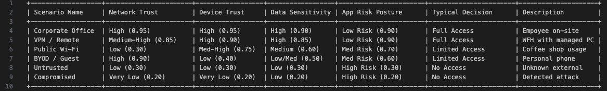

Scenario Name | Network Trust | Device Trust | Data Sensitivity | App Risk Posture | Typical Decision | Description
Corporate Office | High (0.95) | High (0.95) | High (0.90) | Low Risk (0.90) | Full Access | Employee on-site
VPN / Remote | Med-High (0.85) | High (0.90) | High (0.85) | Low Risk (0.90) | Full Access | WFH with managed PC
Public Wi-Fi | Low (0.30) | Med-High (0.75) | Medium (0.60) | Med Risk (0.70) | Limited Access | Coffee shop usage
BYOD / Guest | High (0.90) | Low (0.40) | Low/Med (0.50) | Med Risk (0.60) | Limited Access | Personal phone
Untrusted | Low (0.30) | Low (0.30) | Low (0.30) | High Risk (0.30) | No Access | Unknown external
Compromised | Very Low (0.20) | Very Low (0.20) | Low (0.20) | High Risk (0.20) | No Access | Detected attack

Tescase4: Results
Scenario | Characteristics | Fusion Outcome | Discussion
Corporate Office | High scores across all domains. | Full Access | Trust Score converges to ≈1.0.
Remote / VPN | Network trust dips slightly. | Full Access | Strong Device/App/Data signals maintain Trust Score >0.95.
Public Wi-Fi | Network trust fluctuates (0.02 - 0.40). | Limited → Full | System starts cautious (Limited) due to volatility, but good endpoint health builds trust over time.
Untrusted Device / BYOD | Device score is low (0.40). | Limited → Full | High Network/App trust eventually compensates for the unmanaged device for non-critical data.
Compromised | All domains failing (< 0.30). | No Access | System correctly identifies systemic failure. BetP(Safe)<0.
Untrusted Device | Low trust parameters across domains. | No Access | Strict policy simulation prevents access (BetP(Safe)≈0.14).

Testcase 4: Anaylis
Corporate Office represents themost secure pathway with high trust across all domains (Scores>0.90) and Low variance (Stability). This results in rapid convergence to a Full Access decision with a safe belief value that tends towards1 (Bel(Safe)≈1.0). This baseline confirms the system's ability to recognize ideal conditions. The accumulation of evidence from four stable, high-trust sources creates overwhelming belief in the "Safe" hypothesis, minimizing uncertainty to near zero within 3-5 time steps.
Remote VPN shows scenarios where network trust is slightly lower (0.85) due to traversal over public internet, but Device and App integrity remain high. The fusion engine demonstrates robustness. The slight dip in Network trust is insufficient to overturn the strong positive evidence from the Endpoint (Device/App). This effectively models the ZTNA (Zero Trust Network Access) principle: Apply trust to the entity, not just the network resulting in Full Access.
Public Wi-Fi: Network trust fluctuates significantly (0.02 - 0.40), representing a hostile environment. Since the device is managedm the tust normalizes at a slightly lower score resulting in limited access. The system correctly identifies the risk initially, granting only Limited Access (Bel(Safe)≈0.35−0.67). As the Device and App signals remain stable and high, the system slowly builds trust, eventually upgrading to Full Access if the network signals are verified to be safe. This demonstrates the model's ability to "build trust" over time in an uncertain environment.
BYOD (Bring Your Own Device): High Network trust, but lower Device trust (~0.40) due to lack of management of devices. Initial access is restricted (Bel(Safe)≈0.53). However, unlike a binary "Deny", the system allows the "Good" signals (Network, App) to gradually compensate for the "Bad" signal (Device) as confidence builds. By Step 3, the accumulated stability allows the Trust Score to cross the 0.75 threshold into Full Access, solving the "weakest link" problem for low-sensitivity scenarios.
The Compromised Host:with an active attack, Network, Device, and App all show low scores (< 0.30) and instability. This is the system's "Fail-Safe". The Trust Score plummets to <0.10, resulting in a consistent Deny decision. The Dynamic Weighting discounts the unstable signals, leaving no evidence to support a "Safe" belief.
Untrusted Device in Geofence: Modeled as a strict Zero Trust enforcement where a non-compliant device (~0.30) invalidates the session regardless of location. The simulation resulted in a consistent No Access decision (Bel(Safe)≈0.14). Even if the Network is theoretically secure, the strict parameter tuning for this scenario (setting all domains to Low Trust) demonstrates that the fusion engine respects the "Veto" power of critical failures. If the device is not trusted, the session is not trusted.

The core contribution of this simulation is the demonstration that Stability is a proxy for Trust. In perimeter systems, a fluctuating score (e.g., oscillating between 0.4 and 0.8) might be averaged to 0.6 (Allowed). In this model, that fluctuation spikes Variance, crashes the Weight, and effectively removes the domain from the decision process.This ensures that decisions are made only based on reliable evidence. A sensor that does not present data is treated as Uncertainty rather than "Half Safe". This aligns perfectly with the principle of Fail-Safe Defaults in cybersecurity. These are illustrated by appendices X-y

The implementation validates that a Granular, Two-Stage Fusion approaches (Weighted Sum + Belief Fusion) offers a superior access control decision engine for heterogeneous networks. It accommodates the ambiguity of real-world signals (BYOD, Public Wi-Fi) without being brittle, while maintaining strict security (Denial) when the aggregate environment becomes unstable or hostile. This is summarized in Figure 8.21
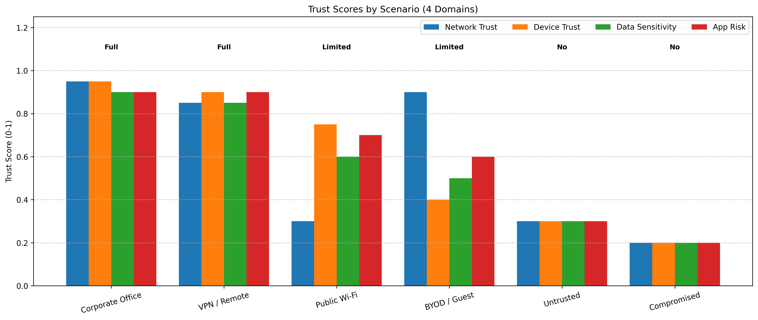
The integration of Dynamic Contextual Weighting with Dempster-Shafer belief fusion provides a superior mechanism for Zero Trust enforcement. It mathematically distinguishes between "Known Bad" (Low Score, High Weight) and "Unknown/Unstable" (High Variance, Low Weight), to achieve a nuanced "Gray Area" decision capability essential for modern, heterogeneous network environments.

Testcase 5: Multidomain Contextually weighted trust determination with temporal decay

Case 1: Multidomain Contextual weighting and Belief Fusion
Most access control models suchRBAC, ABAC) often rely on static policy evaluation. This testcase considers heterogeneous enterpise network environments characterized by BYOD, edge computing, and remote working where trust is ephemeral. Static "trusted" devices may become compromised within minutes necessitating a Continuous Adaptive Risk and Trust Assessment (CARTA) approach. The implementation models this through dynamic Contextual Weighting and weighted belif fusion. Dynamic trust assessment uses signal (metadat input) stability (variance) as a measure of reliability while belief Fusion uses the Dempster-Shafer (DS) Theory of Evidence to mathematically combine conflicting or uncertain inputs. The inputs include parameters in the network, data, device and application domains as discussed in section 4.6.
The network domain represents the transport layer security (Zero Trust Network Access - ZTNA) with corporate office and public wifi scenarios indicating high network trust (0.95and low trust (0.30) with high uncertainty. Sudden latency spikes or routing changes (simulated as "Network Attack") increase varianceand this variance drastically reduces the weight of the Network domain, effectively removing it from the consensus without policies explicitly failing.
Data Domain contextualizes sensitivity and classification of the resource being accessed. High data sensitivity (Trust Score ~0.90 for authorized access) demands higher aggregated belief for access. Low sensitivity allows for "Limited Access" even with lower overall trust. Device Domain represents the health and identity of endpoints and is critical in "BYOD" or "Untrusted Device" scenarios where the score drops (0.20 - 0.40). The fusion engine decides if a secure Network and App can compensate for an insecure Device. Our emulation shows that with weighted fusion, a single low-trust domain (Device) generates significant Uncertainty mass, often preventing a "Full Access" decision unless other signals are overwhelmingly positive. Finally, the application Domain contextualizes the security posture of the requesting application. An application behaving anomalously (high signal variance) would be discounted.

Scenario | Characteristics | Fusion Outcome | Discussion
Corporate Office | High scores across all domains. | Full Access | Trust Score converges to ≈1.0≈1.0.
Remote / VPN | Network trust dips slightly. | Full Access | Strong Device/App/Data signals maintain Trust Score >0.95>0.95.
Public Wi-Fi | Network trust fluctuates (0.02 - 0.40). | Limited → Full | System starts cautious (Limited) due to volatility, but good endpoint health builds trust over time.
Untrusted Device / BYOD | Device score is low (0.40). | Limited →→ Full | High Network/App trust eventually compensates for the unmanaged device for non-critical data.
Compromised | All domains failing (< 0.30). | No Access | System correctly identifies systemic failure. BetP(Safe)<0.10BetP(Safe)<0.10.
Untrusted Device | Low trust parameters across domains. | No Access | Strict policy simulation prevents access (BetP(Safe)≈0.14BetP(Safe)≈0.14).

The integration of Dynamic Contextual Weighting with Dempster-Shafer belief fusion provides a superior mechanism for Zero Trust Access Control compared to static Boolean logic. By mathematically distinguishing between "Known Bad" (Low Score, High Weight) and "Unknown/Unstable" (High Variance, Low Weight), the system achieves a nuanced "Gray Area" decision capability—essential for modern, heterogeneous network environments.

Case 2: Timed Multidomain Contextual weighting and Belief Fusion with 30 min Session(Short Term Memory)-linear
This case expands upon case 1 (Weighted Belief Fusion architecture) by introducing a temporal decay factor. The core thesis is that Trust is a Function of Time. In addition to spatial fusion (Network, Device, Data, App), the system now enforces a linear degradation of trust based on "Session Freshness," effectively creating a dynamic Time-to-Live (TTL) that scales with the initial security posture. Static authentication creates a security vulnerability: the "Implicit Trust Period." Once a user authenticates, they are typically trusted for the duration of a session (e.g., 8-24 hours). Our implementation challenges this by enforcing a Continuous Decay Model. Trust is not a boolean state achieved at login; it is a depreciating asset that must be continuously renewed or allowed to expire. This case implements a linear decay functionwith a maximum session duration of 30 minutes (as informed by reference table sessions). The Final Trust Score is the product of the multidomain trust and the Decay Factor. This ensures that regardless of how secure the device or network is, the system will inevitably revoke access as the session period tends towards the maximum length. The model evaluated the temporal model against the six canonical scenarios to observe how linear decay impacts access durations. The access thresholds remain as per (Table thresholds). The access decision outcomes are sumarized in Table x

Scenario | Characteristics | Temporal Outcome | Discussion
Corporate Office | High initial spatial trust (≈0.97≈0.97). | Full →→ Limited →→ No Access | The high trust buffer ensures a long effective session. Users enjoy ~7 minutes of Full Access before degrading to Limited.
Remote / VPN | Strong signals across Device/App/Data. | Full →→ Limited →→ No Access | Similar to Corporate Office, strong spatial trust provides a durable time-to-live before revocation.
Public Wi-Fi | Network trust fluctuates (≈0.55≈0.55). | Limited →→ No Access | The session starts at Limited Access and the temporal decay pulls it below the minimum threshold rapidly (≈5≈5 mins).
Untrusted Device / BYOD | Device score is persistently low. | Limited →→ No Access | Even with good network trust, the low device score reduces the initial trust buffer, resulting in a significantly shorter session.
Compromised | All domains failing (BetP(Safe)<0.10BetP(Safe)<0.10). | No Access | Denied immediately at t=0t=0; temporal decay is irrelevant.
Untrusted Device (Strict) | Strict policies against unmanaged devices. | No Access | Denied immediately at t=0t=0.

The addition of temporal decay transforms the Trust Fusion engine from a static evaluator into a dynamic lifecycle manager that considers security by mitigating session hijacking risks by enforcing shorter windows of opportunity in risky environments. It also enhances usability as it naturally "upgrades" secure contexts with longer effective sessions compared to insecure ones. This confirms that Time is a critical dimension of Zero Trust, equal in importance to Identity and Device Health.
The Time-Decayed model successfully implements a dynamic "Time-to-Live" (TTL) for trust. It provides a nuanced behavior where Secure Contexts enjoy the full session duration while Risky Contexts suffer from accelerated timeout (Effective TTL < Nominal TTL). This adaptive session management significantly reduces the attack surface for session hijacking.
While linear decay is simple and decays at a stedy rate, it is best for simple, predictable Time-to-Live (TTL) mechanisms where you just want a hard cutoff that approaches zero evenly.

In advanced Zero Trust models Freshness should be decayed exponentially
Because Linear Decay is Too Slow Initiallyand keeps a 50%weight for aan event that is half the session length (15-minutes in this case). In modern network environments, a session can be hijacked or a device compromised in a matter of seconds. Relying heavily on an old signal oe matadata value is dangerous and coud easily result in malware propagation, lateral escalation and data misuse and intrussions in heterogenous enterprise networks. Additionally, Exponential decay allows the system to prioritize absolute freshness during the critical first few minutes (the "Handshake" or "Boot-up" phase). By minute 5, an exponential decay curve drastically drops the value of that initial connection state. This forces a transition to inertia trust or combinations of inertia and metadata values for continous verification.This forces the fusion engine to shift its reliance onto the combination of Historical Inertia an consistent hbehavior history. The logic is: "That initial handshake is no longer fresh. I am no longer going to trust what the device said 10 minutes ago; instead, I am going to trust the consistent behavioral history it has built up over the last 10 minutes." Linear decay turns trust into a simple ticking timer. Exponential decay treats trust like a highly volatile element that must be instantly verified and then immediately handed off to behavioral momentum in line with continuou verification and continouos improvement principles of zero trut enforcement

Case 3: Timed Multidomain Contextual weighting and Belief Fusion with 30 min Session(Short Term Memory)-Exponential
This case explores the theoretical friction between continuous authentication and session longevity by introducing Exponential Temporal Decay into the Weighted Belief Fusion architecture. The core thesis expands upon the premise that Trust is a Function of Time by evaluating how an aggressive decay curve impacts the "Effective Session Length" in various contextual states. Static authentication protocols trust a user for the entirety of their session (the "Implicit Trust Period"). While the previous linear temporal decay model addressed this by enforcing a steady erosion of trust, an exponential model challenges the fundamental concept of a "Session." By applying an exponential decay function, the architecture mathematically asserts that the instant a cryptographic handshake concludes, its value plummets. This is illustrated in Table x. This case evaluated this model against the six canonical scenarios, noting the severe compression of access durations compared to the linear variant.

Scenario | Characteristics | Exponential Outcome | Comparison to Linear Decay
Corporate Office | High initial spatial trust (≈0.95≈0.95). | Limited →→ No Access | The "Full Access" buffer is almost instantly erased; the session terminates in fraction of the linear time.
Remote / VPN | Strong signals across Device/App/Data. | Limited →→ No Access | The high-trust buffer is insufficient to combat the exponential curve.
Public Wi-Fi | Network trust fluctuates (≈0.55≈0.55). | Immediate No Access | The combination of low initial trust and rapid depreciation denies access almost immediately.
Untrusted Device / BYOD | Device score is persistently low. | Immediate No Access | Evaluated as too risky to grant even a momentary session.
Compromised | All domains failing (BetP(Safe)<0.10BetP(Safe)<0.10). | No Access | Irrelevant; spatial trust correctly denies access before time can decay.

This case effectively establishes a dynamic "Time-to-Live" (TTL) that is heavily front-loaded. For example with a decay constant of λ=3.0 over a 30-minute session, the emulation shows that the final trust score the final trust score will crash through the "Limited Access" threshold (0.75) and plummet into "No Access" (<0.45) within the first 5−10 minutes. With this session hijacking becomes practically impossible. Stolen cookies or transient network compromises are suffocated by the rapid expiration of the authentication event's initial weight. This is great in ensuring little to no chances of intrusion and data misuse as a result of reply attacks or lateral escalation. This however results in unusability as the Operational Reality. This is because in a purely exponential decay model, Users would be forcefully ejected from their applications every few minutes causing complete operational paralysis and rendering it unusable in a production environment.

This therefore indicates that Exponential Temporal Decay perfectly validates the architectural necessity of an Ensemble Trust Model such that if the value of an initial authentication event must decay rapidly for security reasons (Exponential Decay), then the system must have a mechanism to replace that lost value with operational signal ormetdata vaues for continuous verification and behavior consistency building. An enseble model thatconsiders multiple domains, an inertia trust value and temporal decay resolves the usability vs security paradox. It intentionally utilizes the aggressive exponential decay to kill off the "Fresh Verification" signal, but uses that identical temporal function to inversely transfer weight onto the user's domains including the trust Inertia.
Therefore, exponential decay proves that sustained Zero Trust enforced access cannot be supported with continuous verification (which decays), but must be carried by continuous behavioral consistency (which accumulates).

Case 4: Ensemble Multidomain Contextual weighting and Belief Fusion with 30 min Session(Short Term Memory) and 48 hour Inertia Trust (Long Term Memory)

This case considers the theoretical underpinnings of the Ensemble Trust Model. By hybridizing Short-Term Spatial Fusion (Dempster-Shafer) with Long-Term Temporal Inertia (Exponential Decay), it establishes a system that resolves the fundamental tension in Zero Trust: Security vs. Usability. Zero Trust Architectures (ZTA) often treat every access request as a discrete, independent event. This leads to the "Jittery Access" problem, where minor, transient fluctuations in network latency or device CPU usage cause authentication failures. This Ensemble Model posits that Trust has Momentum (Inertia) such that an untrusted history or inertia trust requires significant evidence to change the trust score or trajectory for a specific context. This implies that a user with a strong history of safe behavior should not be revoked due to a single dropped packet (Noise). Conversely, a user with a history of compromise should not be reinstated due to a single clean packet (Beaconing). This is sigbificant in handling On-Off attacks especially in highly volatile environment such as virtualized infrastructure, BYOD and IoT environments which have significantly changed the posture and threalandscape of heterogenous enterprise environments

Scenario | Characteristics | Ensemble Outcome | Discussion
Corporate Office | Consistently high signals over time. | Stable Full Access | High fresh signal transitions smoothly into high inertia. Trust score is practically locked at ≈1.0≈1.0.
Remote / VPN | Minor network jitter during a mature session. | Stable Full Access | The system relies on the historical inertia of the device/user. Transient VPN drops are absorbed without access revocation.
Public Wi-Fi | High variance in the fresh network signal. | Limited →→ Full Access | System starts cautiously relying on fresh signals. As evidence of good device health accumulates over time, inertia builds, upgrading access to Full.
Untrusted Device / BYOD | Device lacks history or has low health. | Limited Access | High network trust keeps the user in Limited Access, but the lack of positive device history prevents the ensemble score from reaching Full Access.
Compromised | Sudden, systemic failure across domains. | Immediate No Access | If variance (σ2σ2) spikes aggressively due to anomalous behavior, the dynamic weight drops, causing the fusion engine to strip access despite any previous positive history.
Beaconing Attacker | A known bad user sends a single perfect signal. | No Access | The system's memory (1−Wshort1−Wshort​) heavily weights the prior history of malicious behavior. A single "clean" packet cannot overcome the inertia of negative trust.

The Ensemble Model successfully implements Contextual Durability. It moves Zero Trust from a stateless "Packet Fighter" to a stateful "Behavior Engine," enabling robust security that respects the continuity of legitimate work.

